# Overview

The Chatterbox is a switch scanning communication device which provides auditory feedback to guide the user while scanning. The Design Rationale is intended to provide designers and maker information about the design process and design decisions behind the development of the Chatterbox.

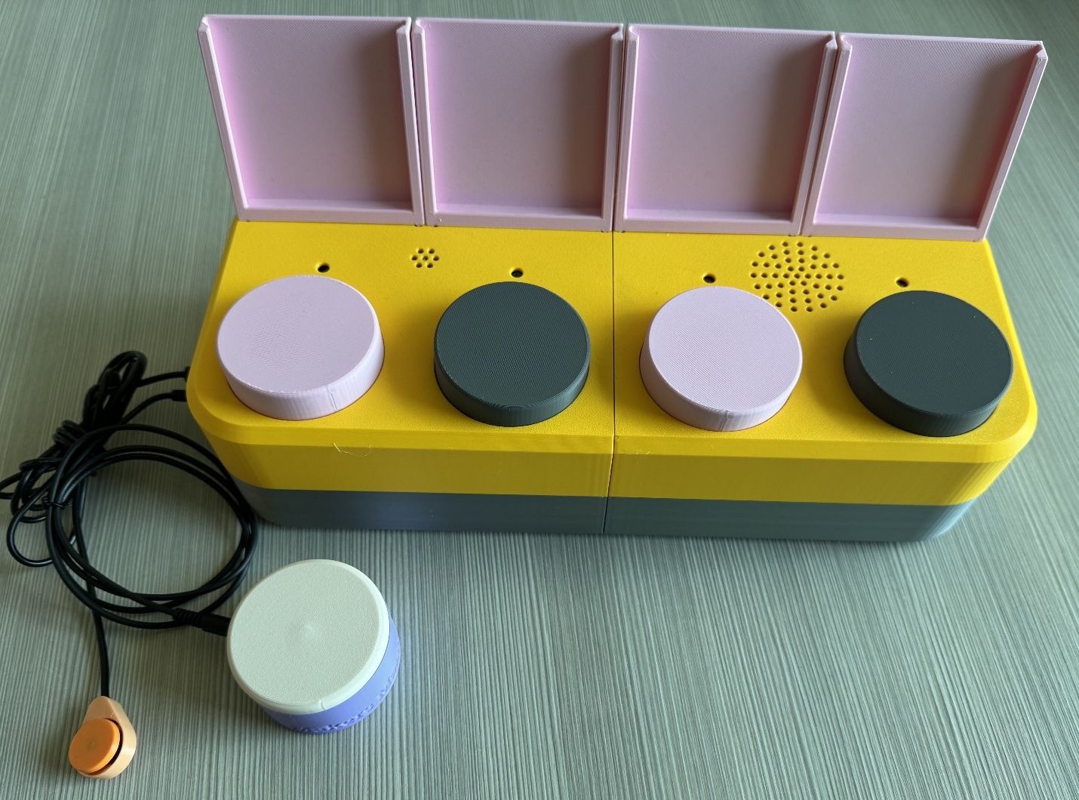

The Design Rationale details development chronologically. For full details on the current published version of the device, you may skip to the Detailed Design section.

Contents

Overview 1

Introduction 6

Requirements 6

Problem Statement 6

User Needs 6

Functional Requirements 7

Evaluation Criteria 7

Constraints 7

Research 8

Background 8

Commercially Available Options 8

AbleNet Inc. Talking Brix 2 8

Cheap Talks 4 & 8 – Direct Scan and Jacks 9

Talk 4 with Levels 10

Announcer with 6 Levels 10

Tech Scan and Smart Scan Devices 11

Talk About! Communicator 12

iTalk 4 13

Compartmentalized Communicators 14

DIY / Maker-Friendly Options 15

Partner – Assisted Auditory Scanning (PAAS) 15

Open Playback Recorder 15

Single Message Playback Switch 16

Ideation 18

I01 - Push pins for electrical connection 18

I02 - Modifying Open Playback Recorder 18

I03 - Array of Single Message Playback Switches 18

I04 - Using mechanical keyboard switches for direct selection buttons 18

Ideation Decisions 18

Conceptual Designs 20

Use Cases 20

General use flow 20

Single switch scanning 21

Double switch scanning 21

Directly choosing to play a message instead of switch scanning 21

Secondary users recording messages 21

Secondary users observing an end-user 22

Secondary users changing image cards for messages 22

Concept 1: Single Message Playback Switch Array 22

Physical Component / Enclosure 24

Electrical Components 24

Code Structure / Function 24

Concept 2: Modified Open Playback Recorder – Direct Message Access 24

Physical Component / Enclosure 26

Electrical Components 26

Code Structure / Function 26

Concept 3: Modified Open Playback Recorder – No Direct Message Access 26

Physical Component / Enclosure 28

Electrical Components 28

Code Structure / Function 28

Concept Decisions 28

Prototyping 29

Solderless Breadboard 29

Goals for this prototype: 29

Electrical Components 30

Code Structure / Function 31

Function and number of pins 34

Microcontroller and peripherals comparison 35

Memory usage optimization 36

Soldered Protoboard 37

Physical Component / Enclosure 37

Electrical Components 42

Code Structure / Function 42

Printed Circuit Board (PCB) Prototype 42

Physical Components / Enclosure 44

Electronic Components 46

Prototype Decisions 50

Testing 51

Detailed Design 51

Overview 51

Enclosure 52

Direct Access Buttons 61

Electrical Components 67

Firmware 74

Verification and Validation 78

Verification 78

Verification Objective 78

Verification Methods 78

Verification Matrix 79

Verification Summary 84

Validation 85

Validation Objective 85

Validation Questions 85

Validation Matrix 87

Validation Summary **Error! Bookmark not defined.**

Traceability **Error! Bookmark not defined.**

Verification and Validation Summary 93

Design Transfer (a bit meta discussion now) **Error! Bookmark not defined.**

Opportunities for Improvement 94

Physical Component / Enclosure 94

Electrical Components 94

Code Structure / Function 94

Appendix 95

Verification Test Descriptions 95

Firmware testing 95

Current Draw/Battery Life Measurement and Calculation 96

3D print testing 106

# Introduction

The request for this device came from staff at a Surrey School District school for students with disabilities. The staff were looking for an affordable device to help students with visual impairment learn switch scanning for communication devices. The goal of the device is to help students trial switch scanning communication devices before purchasing a more expensive commercial option. The device requires auditory feedback as it is intended for users with visual impairment, and many commercially available options use visual feedback for switch scanning.

The device allows users to record their own messages to play back when selected using switch scanning, or direct selection of a message. Messages can range from single words to full sentences or sections of songs. The messages allow users who have complex communication needs to interact with other people and participate in group activities. The simplicity of the device helps teach users about switch scanning, before using more complex switch scanning communication devices.

The device is intended for users with complex communication needs and visual impairments, including users who are deaf-blind, blind, visually impaired, or have cerebral palsy (CP).

# Requirements

## Problem Statement

Design an OpenAT device that enables a user with visual impairment to perform switch-enabled auditory scanning.

## User Needs

|  |  |
| --- | --- |
| G01 | A switch scanning communication device that uses auditory feedback for switch scanning. |
| G02 | Device is simple to help teach users how to switch scan rather than learning how to use the device. |
| G03 | Has integrated switches to directly play and record messages. |
| G04 | The device can do single and perhaps dual switch scanning. |
| G05 | The volume of the device can be controlled. |
| G06 | The delay between scanning messages can be controlled. |
| G07 | The device can hold images on paper near each switch to represent the message. |
| G08 | The device can record and play at least three messages. |
| G09 | The device is more affordable than current commercially available options. |
| G10 | The device is small enough to fit on a user’s lap tray. |
| G11 | The device has different message levels to store and playback sets of messages. |
| G12 | The device shows which level it is on. |
| G13 | The device shows which message is being played/recorded. |
| G14 | The device must be able to clean. |
| G15 | Integrated buttons should not be angles |
| G16 | It should be easy to record messages. |

## Functional Requirements

|  |  |
| --- | --- |
| F01 | Secondary users must be able to record their own messages. |
| F02 | Messages up to a minute in length must be possible to record. |
| F03 | The device must record at least three separate messages. |
| F04 | The device must work with single switch scanning. |
| F05 | Users must be able to add message labels or pictures to help identify the messages (76x76 mm minimum size). |
| F06 | The delay between messages while switch scanning can be modified. |
| F07 | The volume of the playback must be adjustable by a secondary user. |
| F08 | The device must be able to be cleaned with a damp cloth. |
| F09 | The device must fit on a student’s lap tray (maximum length 330 mm). |
| F10 | The device must be able to record and play at least two different levels of messages. |
| F10a | The device must have a means to change the level. |
| F10b | The device must have a way to indicate the current level. |
| F11 | Integrated buttons on the device must be parallel to the surface the device is mounted or placed upon. |
| F12 | The device enables switch-enabled auditory scanning |
| F12a | The device plays pre-recorded messages when triggered by primary user. |
| F12b | The device must be able to record a message for each position. |
| F12c | The device must have a visual indicator for each position. |
| F12d | The device must have a means for indicating the current position. |
| F12e | The device must play a selected message again when selected by the user. |
| F13 | The device must have a way to indicate which position is being recorded. |
|  |  |

## Evaluation Criteria

|  |  |
| --- | --- |
|  | The device should have integrated buttons for direct access |
| NF01 | The device should have separate jacks for connecting external assistive switches for direct access. |
| NF02 | The device should provide an option for two-switch scanning. |
|  | The device should have visual feedback for secondary users, or users with partial vision. |
|  | The device should have the option to have integrated buttons with different tactile tops. |
|  | The device should have |
|  |  |

## Constraints

|  |  |
| --- | --- |
| C01 | The device must cost less than other commercially available options ($300 CAD). |
| C02 | The device must be makeable by a volunteer. |
| C03 | Any required custom printed circuit boards (PCBs) are makeable through low-volume prototyping services. |
| C04 | The device design must be licensed as open source hardware. |
| C05 |  |

# Research

Research on existing devices was conducted between September 10th and 18th, 2024. Research was conducted by searching Google for “auditory scanning devices”, “switch scanning devices”, and using “DIY”, and “homemade” with the previous searches. The augmented and alternative communication (AAC) team that requested this device also suggested commercially available devices as starting points for the design.

## Background

Simple switch scanning AAC devices are used by people with complex communication needs and limited motor function. Messages are often short (single words or short statements), but may be longer depending on the user’s needs and the context of the use.

## Commercially Available Options

Options that can be purchased but not made by a maker.

### AbleNet Inc. Talking Brix 2

|  |  |
| --- | --- |
| **Title / Name of device** | Talking Brix 2 |
| **Link** | <https://www.ablenetinc.com/talkingbrix-2/> |
| **Author** | AbleNet Inc. |
| **License** | N/A |
| **Cost** | $365.00 CAD |

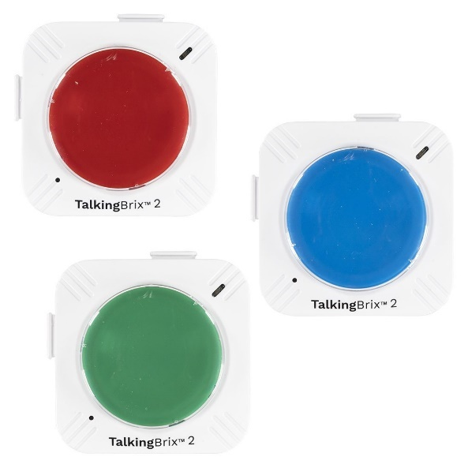

The Talking Brix 2 come in sets of three individual playback buttons. Each button works separately, can record up to 10 seconds of audio, and have rechargeable batteries. To record messages, the user moves a switch on the bottom of the base to “Rec” and holds the Brix button down while recording the message. When the switch is turned to “On”, the recorded message will play when the button is pressed. The Brix can be physically connected using the slots and tabs on the sides; however, these connections are for physical mounting only and each Brix will still need to be pressed to be activated.

|  |  |
| --- | --- |
| **Requirements Met** | **Requirements Unmet** |
| F01, F03 | F02, F04-F07 |

#### Useful Design Features

The tabs and slots on the sides of the Brix to connect them are well made. There are also push pins on the tabs which appear to be useful for creating electrical communication among the Brix, although they are unused in this design.

Each Brix has a magnet in the bottom to allow for mounting on metal surfaces.

### Cheap Talks 4 & 8 – Direct Scan and Jacks

|  |  |
| --- | --- |
| **Title / Name of device** | Cheap Talks 4 & 8 – Direct Scan and Jacks |
| **Link** | <https://enablingdevices.com/product/cheap-talks-4-8-direct-scan-jacks/> |
| **Author** | Enabling Devices |
| **License** | N/A |
| **Cost** | $319.95 – $339.95 (USD) |

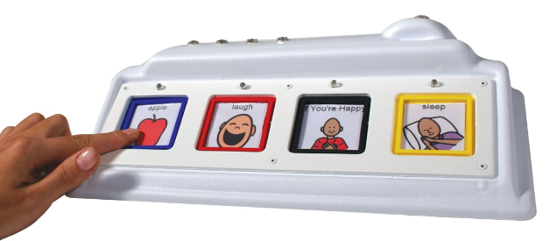

The Cheap Talks 4 & 8 – Direct Scan and Jacks can record and replay either four (4) or eight (8) messages. Messages can be up to 37.5 seconds in length on each button. The device supports single or dual switch scanning with external switches in eight (8) scanning modes. Users can also press the buttons on the device to directly select one of the messages to play.

Users record messages by holding the “Record” button and intended message button down simultaneously. Dials and buttons on the back allow users to change the volume, scanning speed, and scanning mode.

|  |  |
| --- | --- |
| **Requirements Met** | **Requirements Unmet** |
| F01, F03, F04, F07 | F02, F05, F06 |

#### Useful Design Features

Options of multiple [scanning methods](https://enablingdevices.com/wp-content/uploads/2017/09/Scan-Modes.pdf) are useful and described well.

The buttons also light up when playing messages or other auditory cues for scanning.

### Talk 4 with Levels

|  |  |
| --- | --- |
| **Title / Name of device** | Talk 4 with Levels |
| **Link** | <https://enablingdevices.com/product/talk-4-wlevels/> |
| **Author** | Enabling Devices |
| **License** | N/A |
| **Cost** | $299.95 (USD) |

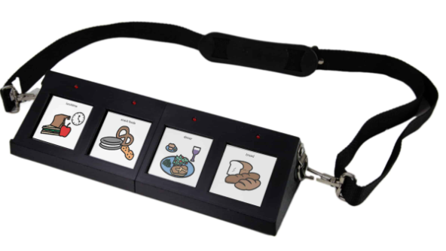

The Talk 4 is like the Cheap Talks, but only has one jack for switch scanning. It is a more portable version, with 12 levels of messages, and up to 300 seconds of memory for recorded messages.

|  |  |
| --- | --- |
| **Requirements Met** | **Requirements Unmet** |
| F01, F03, F04 | F02, F05-F07 |

#### Useful Design Features

Levels are useful for increasing the number of possible messages.

### Announcer with 6 Levels

|  |  |
| --- | --- |
| **Title / Name of device** | Announcer with 6 Levels |
| **Link** | <https://enablingdevices.com/product/announcer-w6-levels/> |
| **Author** | Enabling Devices |
| **License** | N/A |
| **Cost** | $339.95 (USD) |

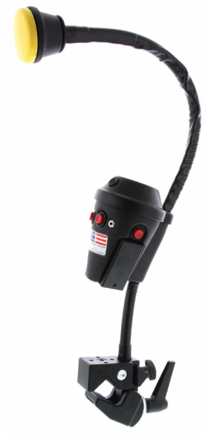

The Announcer has six (6) levels of messages, with 300 seconds of message recording time. The Announcer has a built-in switch and mounting clamp, and can be activated with an external switch. The beginning of messages are played at a lower volume than the messages when selected/played back.

|  |  |
| --- | --- |
| **Requirements Met** | **Requirements Unmet** |
| F01, F02, F03 | F04, F05-F07 |

#### Useful Design Features

Playing the message cue at a lower volume than the message may be useful.

### Tech Scan and Smart Scan Devices

|  |  |
| --- | --- |
| **Title / Name of device** | Tech Scan and Smart Scan Devices |
| **Link** | <https://www.turningpointtechnology.com/Comm/Auditory.asp> |
| **Author** | Turning Point Technology |
| **License** | N/A |
| **Cost** | $1,018 - $2,450 USD |

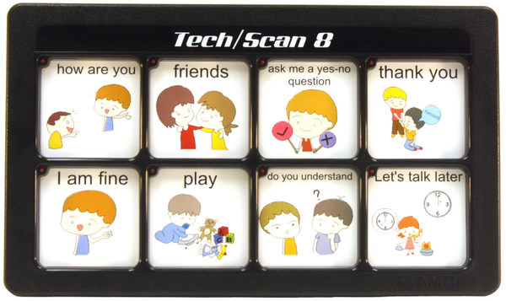

The Tech Scan and Smart Scan devices are direct and switch scanning devices with different numbers of messages. The devices have either eight (8) or 32 messages/square for message selection. Each device also has multiple levels for more messages, and standard message length is 4.5 seconds.

|  |  |
| --- | --- |
| **Requirements Met** | **Requirements Unmet** |
| F01, F03 | F02, F04, F05-F07 |

#### Useful Design Features

No new design features other commercially available options haven’t included.

### Talk About! Communicator

|  |  |
| --- | --- |
| **Title / Name of device** | Talk About! Communicator |
| **Link** | <https://www.adaptivetechsolutions.com/pd-talk-about-communicator/?srsltid=AfmBOoq3FJIaj412QSOrk76TpdaQk041moJlEOmOddBrGyGvxO57XSLE> |
| **Author** | Adaptive Tech Solutions |
| **License** | N/A |
| **Cost** | $27.58-$37.83 (USD) |

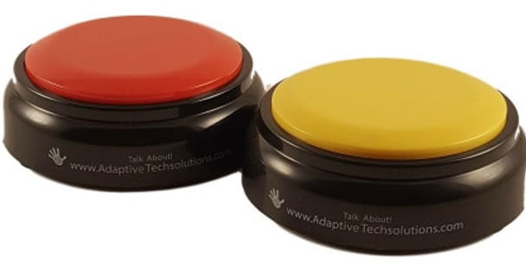

Records and plays back messages up to 20 seconds long. Includes non-slip pads on the bottom, and there is a switch jack version for use with external switches. Additionally has a belt clip so make it wearable/portable.

|  |  |
| --- | --- |
| **Requirements Met** | **Requirements Unmet** |
| F01 | F02-F07 |

#### Useful Design Features

Can be used with an external switch, and option for belt clip is interesting.

### iTalk 4

|  |  |
| --- | --- |
| **Title / Name of device** | iTalk 4 |
| **Link** | <https://www.ablenetinc.com/italk4/> |
| **Author** | AbleNet, Inc. |
| **License** |  |
| **Cost** | $275 (USD) |

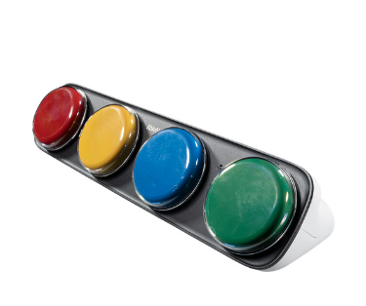

The iTalk 4 offers four individual messages with three message levels (12 messages total) with a total of six (6) minutes of recording time. Each button corresponds to a message, and each message can be recorded independently. External switches can be used for each message; however, there is not a switch scanning mode.

|  |  |
| --- | --- |
| **Requirements Met** | **Requirements Unmet** |
| F01, F03 | F02, F04-F07 |

#### Useful Design Features

Individual recording of each message is useful, as are the levels.

### Compartmentalized Communicators

|  |  |
| --- | --- |
| **Title / Name of device** | Compartmentalized Communicators |
| **Link** | <https://enablingdevices.com/product/compartmentalized-communicators/?srsltid=AfmBOoqLPBpBhjRKIVVAHyzmXBPQkFkR4kDSdKowHBe27DFtp3_HjVcO> |
| **Author** | Enabling Devices |
| **License** |  |
| **Cost** | $179.95 - $269.95 (USD) |

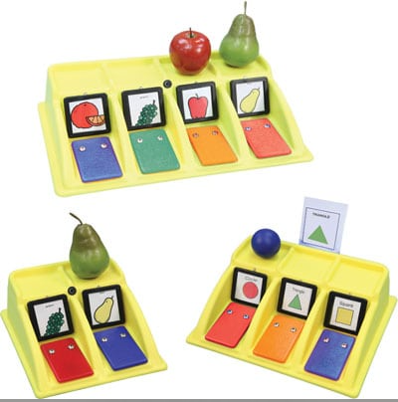

The Compartmentalized Communicator has two-, three-, or four-compartment versions. Each compartment can record up to a five (5) second message that is played back when the plate is pressed. There are spaces for images and objects to be placed above each compartment. There is no switch scanning option.

|  |  |
| --- | --- |
| **Requirements Met** | **Requirements Unmet** |
| F01, F03, F07 | F02, F04-F06 |

#### Useful Design Features

Having space for both an object and an image may be useful.

Having the switches flat (not angled) makes it easier for some users to press.

## DIY / Maker-Friendly Options

Options that can be made by a maker.

### Partner – Assisted Auditory Scanning (PAAS)

|  |  |
| --- | --- |
| **Title** | Partner – Assisted Auditory Scanning |
| **Link** | <https://communication.bridgeschool.org/intervention/aac-system-design-guiding-principles/aac-system-design-examples-of-aac-tools-and-techniques/> |
| **Author** | N/A |
| **License** | N/A |
| **Cost** | N/A |
| **Test Build (Y/N)** | N/A |
| **Add to Library (Y/N)** | N/A |

Partner-Assisted Auditory Scanning relies on a partner going through a series of options verbally, and having the user select from the choices they present. The series of options can be developed by anyone, and can be presented in various ways (pictures, words, etc.).

|  |  |
| --- | --- |
| **Requirements Met** | **Requirements Unmet** |
| None | F01-F07 |

### Open Playback Recorder

The Open Playback Recorder is an open-source device that can record three lists of voice messages that its user can playback via the trigger of an accessible button connected through a 3.5 mm mono jack. It aims to assist users with communication difficulties by giving them alternative methods to engage in conversation. This device has functionality like AbleNet’s Big Mack or Step by Step.

|  |  |
| --- | --- |
| **Title** | Open Playback Recorder |
| **Link** | <https://www.makersmakingchange.com/s/product/open-playback-recorder/01tJR000003DNOVYA4> |
| **Author** | Neil Squire/Makers Making Changes |
| **License** | CERN OHL-W v2, GPL-3.0, CC BY SA 4.0 |
| **Cost** | $90 (CAD) |
| **Test Build (Y/N)** | Y |
| **Add to Library (Y/N)** | Already in library |

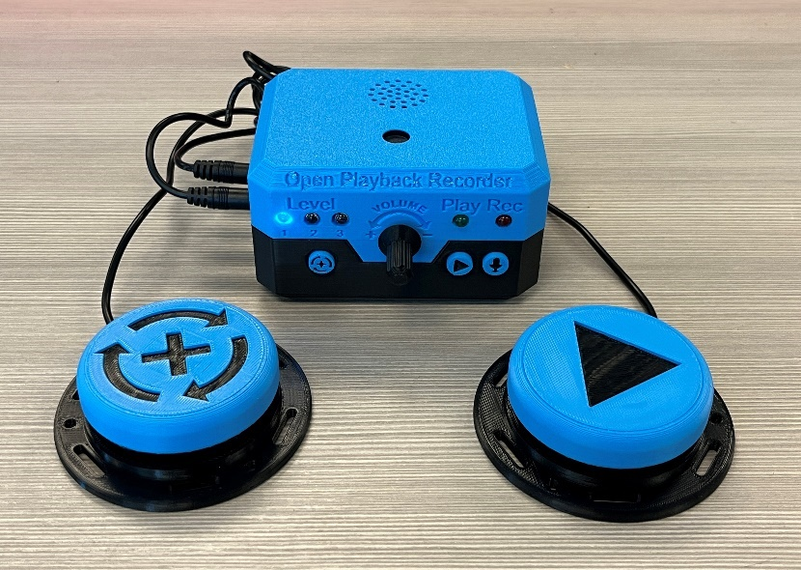

The Open Playback Recorder allows users to record and switch scan messages to engage in communication. There are three levels to record different messages, and users record a series of messages on each level. Recording, switching levels, and scanning messages can all be done using assistive switches, or built-in switches on the device.

Messages cannot be modified or accessed directly; users must re-record all messages on a level at once, and must switch scan to access messages.

|  |  |
| --- | --- |
| **Requirements Met** | **Requirements Unmet** |
| F01-F04, F07 | F05, F06 |

#### Useful Design Features

Most of the components and firmware from this device can be used as the basis for the Auditory Scanning Blocks device.

### Single Message Playback Switch

The Single Message Playback Switch is a switch adapted device that can store and play back a single 30 second message. The device can be used both as a toy or as a communication aid. A commercially available voice recording button is modified so that it can be activated using a secondary assistive switch with a 3.5 mm plug.

|  |  |
| --- | --- |
| **Title** | Single Message Playback Switch |
| **Link** | <https://www.makersmakingchange.com/s/product/single-message-playback-switch/01tJR000001HyonYAC> |
| **Author** | Neil Squire/Makers Making Changes |
| **License** | CERN OHL-W v2, GPL-3.0, CC BY SA 4.0 |
| **Cost** | $12.50 (CAD) |
| **Test Build (Y/N)** | Y |
| **Add to Library (Y/N)** | Already in library |

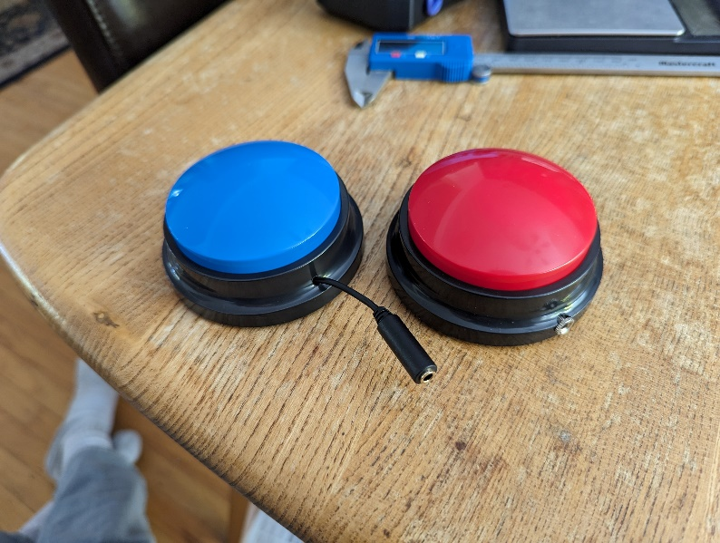

|  |  |
| --- | --- |
| **Requirements Met** | **Requirements Unmet** |
| F01, F03 | F02, F04-F07 |

#### Useful Design Features

The useful functions are the same as the Talking Brix 2.

# Ideation

## I01 - Push pins for electrical connection

Use electrical push pins for the electrical connections among the individual blocks, like the Talking Brix 2 have. These pins wouldn’t help with the physical connection among the blocks, so would require a strong physical connection, like the Talking Brix 2 sliding and locking together.

## I02 - Modifying Open Playback Recorder

Start with the firmware and electrical components of the Open Playback Recorder, and modify them as needed to meet the unmet functional requirements. The firmware will require minimal changes to adjust how messages are recorded and played back. Some components will be removed, some added, and the custom PCB will need to be redesigned for different functions and form factor.

Modification would include:

* Change in size and shape to meet client’s needs
* Removing external switch access to record and level changes
* Adding direct access to record messages instead of levels
* Adding internal switches for direct access to each message
* Adding option to change delay between messages while switch scanning
* Add ability to use two-switch scanning

## I03 - Array of Single Message Playback Switches

The Single Message Playback Switches already include recording, playback, and direct access control. An array of them could be controlled with a microcontroller to allow switch scanning across the single message switches.

Using the array would be cheap and straightforward to implement, but would limit recording time, not allow message levels, or control over volume.

## I04 - Using mechanical keyboard switches for direct selection buttons

Mechanical keyboard switches come with many options for activation force and feedback style, so they are an interesting option for making customizable switches. Designing a device to be hot swappable (be able to change keyboard switches without soldering) allows users to easily customize their switch.

The simplest way to make a switch hot swappable is to add a [hot-swap socket](https://www.digikey.ca/en/products/detail/mill-max-manufacturing-corp./3305-0-15-80-47-27-10-0/13901970?utm_adgroup=&utm_source=google&utm_medium=cpc&utm_campaign=PMax%20Product_High%20ROAS%20Categories&utm_term=&productid=13901970&utm_content=&utm_id=go_cmp-20222745078_adg-_ad-__dev-c_ext-_prd-13901970_sig-EAIaIQobChMIoueXsojziAMVGln_AR1Q8zsCEAQYASABEgIiJfD_BwE&gad_source=1&gclid=EAIaIQobChMIoueXsojziAMVGln_AR1Q8zsCEAQYASABEgIiJfD_BwE) to a PCB. The socket must be soldered in, but it allows the keyboard switch to be inserted and changed without additional soldering. SparkFun created an [open-source breakout board](https://github.com/sparkfun/Cherry_MX_Switch_Breakout) for [Cherry MX switches](https://www.cherry.de/en-gb/products/mx-switches).

## Ideation Decisions

|  |  |  |
| --- | --- | --- |
| Idea | Decision (Abandon, Modify, Proceed) | Justification |
| I01 - Push Pins | Abandon | The requestors did not need a modular device. |
| I02 – Modified Open Playback Recorder | Proceed | This option would allow us to meet all the requirements of the requestors. |
| I03 – Array of single messages | Abandon | This option meets most of the requirements of the requestor and will likely be the most affordable option; however, the requestors stated they must have multiple message levels. |
| I04 – Mechanical keyboard switches | Abandon | While a useful option for other projects, the customization option was not necessary for this project. |

# Conceptual Designs

## Use Cases

Different use cases were created to help guide the concept development, prototyping, and design. These use cases account for end-users with different levels of ability, and secondary users who are recording messages and selecting levels. These use cases were informed by conversations with the original requestors of the device.

### General use flow

The general use goes through the initial setup through to use by a primary user. Each user scenario/use case is described in detail following the flow diagram.

### Single switch scanning

The device will need to be able to play messages with single switch scanning. Users can press an assistive switch to start the device scanning through the messages (playing either a part of a message, or the whole message), and press it again to select and play a message. Regardless of the ability of an end-user they will need to:

* Initiate switch scanning with their assistive switch
* Hear the auditory feedback
* Have time to process the auditory feedback and decide if it is the message they would like to select
* Use their assistive switch to select a message

#### End-user with partial sight

An end-user with partial sight will be able to receive auditory and some visual feedback. It could be useful for them to receive visual feedback to indicate which message is currently being played and will be selected if they activate their switch.

#### End-user without sight

An end-user without sight would rely solely on the auditory feedback from the device to know which message will be played when they activate their assistive switch.

### Double switch scanning

Double switch scanning allows users to activate one switch to advance through scanning options and the other to select an option. Users will need to:

* Initiate switch scanning with their assistive switch
* Hear the auditory feedback
* Have time to process the auditory feedback and decide if it is the message they would like to select
* Use a second assistive switch to advance to the next option once they know if they would like to select the current option
* Use a second assistive switch to select their desired message when it is available

### Directly choosing to play a message instead of switch scanning

A primary or secondary user can press one of the direct access switches to play a message directly.

* Select which message to play back
* Press direct access switch to play message

### Secondary users recording messages

Secondary users recording messages are assumed to not have severe disabilities. Switches can be small, and feedback can come through any modality. Secondary users will need to be able to:

* Switch the device to record messages
* Confirm the device is in record mode
* Select the level to record on
* Confirm which level the device is recording on
* Select the message to be recorded
* Confirm which message is being recorded
* Record message
* Exit recording mode
* Playback message to confirm it is correct

Secondary users will be the only ones recording messages and changing levels.

### Secondary users observing an end-user

A secondary user may want to observe and help the primary user when learning the device. While doing so, it would be useful for them to know which message is being played at different times.

* Break into flow of initial setup to end-user using device
  + User story flow

### Secondary users changing image cards for messages

A secondary user may switch the image cards out to represent what each message means on a set level.

* Identify the level the device is set to
  + Change level if necessary
* Identify the messages on each switch
  + Record new messages if necessary
* Place image cards above each switch to represent the message

Only secondary users are expected to change the image cards.

Three initial concepts were created for the device. All three concepts used existing devices on the MMC website as the base for the designs.

## Concept 1: Single Message Playback Switch Array

[Single Message Playback Switches](https://www.makersmakingchange.com/s/product/single-message-playback-switch/01tJR000001HyonYAC) are mounted together and can be controlled through single or two-switch scanning. A sketch of the array is below:

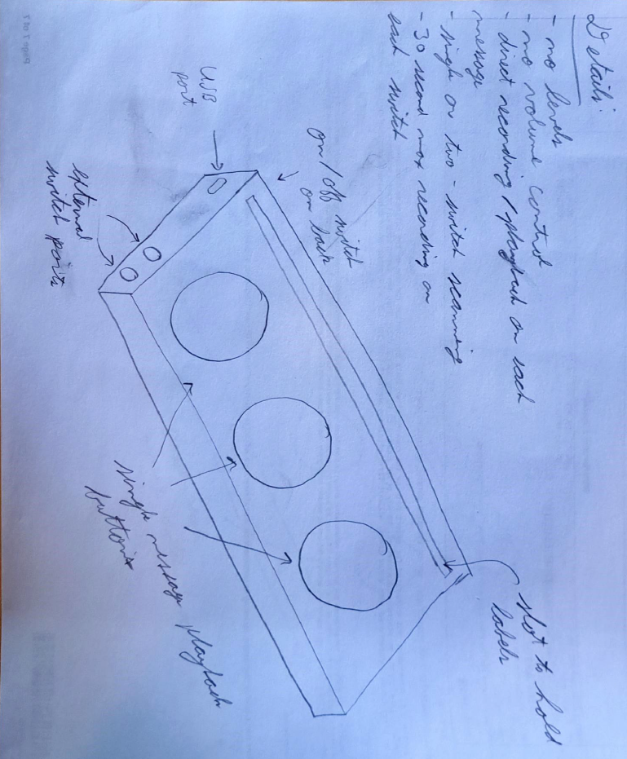

Concept 1 would hold the voice recording buttons from the Single Message Playback Switch to record and play back messages. A microcontroller would be added to allow single or two-switch scanning across the voice recording buttons. Each switch and the microcontroller would need batteries, and the microcontroller would be turned on and off with a switch on the back of the device. Ports for accessing the microcontroller and attaching the external switches for scanning would be on the side of the device.

Users could use external assistive switches to switch scan across the voice recording buttons, or press the buttons to directly select and play back a message.

A cardboard mock-up was also created to get a better idea of the size and shape of this design. Note that there were only three buttons shown in the cardboard mock-up. This was because of the size limitation on the length of the device; four buttons with clearance between them would have been wider than the maximum length.

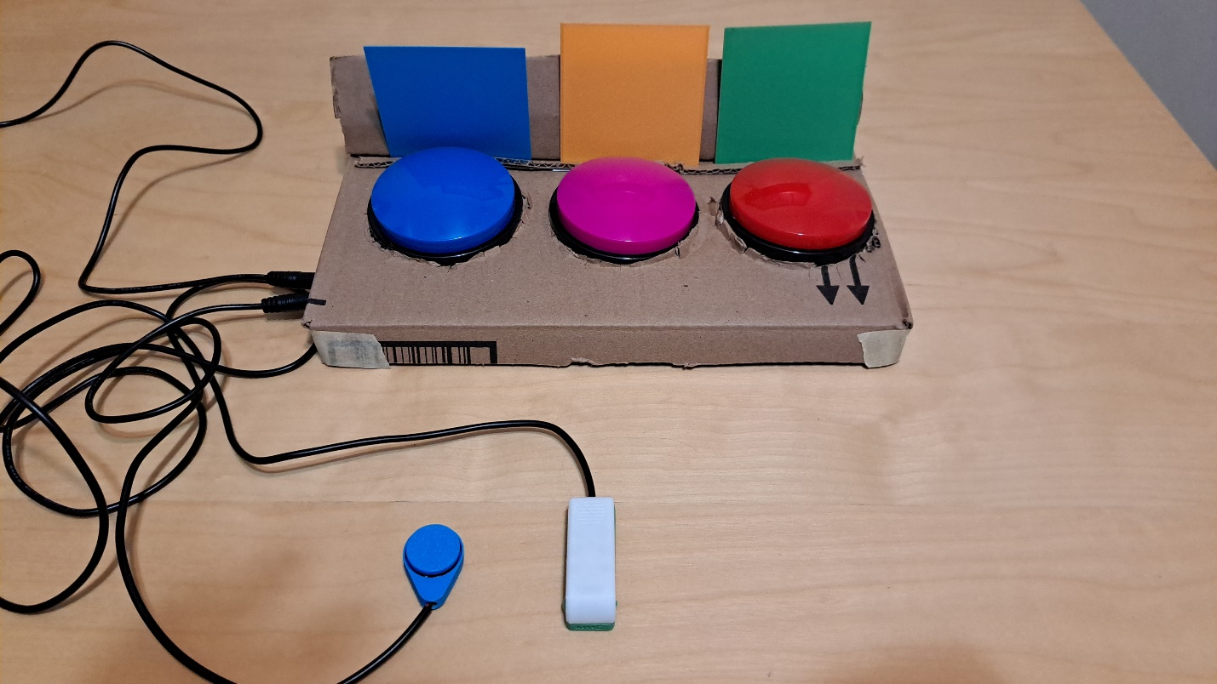

### Physical Component / Enclosure

Concept 1 would consist of a 3D printed enclosure to surround the [voice recording buttons](https://www.amazon.ca/gp/product/B09V1JJ3D1/ref=ppx_yo_dt_b_asin_title_o00_s00?ie=UTF8&psc=1) and house the electrical components of the device. The enclosure would include a slot behind the voice recording buttons to allow caregivers/secondary users to place images behind the switches to represent the message that will be played.

Due to the size constraint of the design, only three buttons could be mounted together this way.

### Electrical Components

Concept 1 would require three voice recording buttons, a microcontroller, LEDs, resistors, and switch jacks for the external switches. This concept would likely be simple enough not to require a custom PCB.

### Code Structure / Function

The code would only be used to control switch scanning with these buttons as any recording and playback of the messages is already handled in the voice recording buttons.

The general flow of the code is demonstrated in the figure below.

## Concept 2: Modified Open Playback Recorder – Direct Message Access

A single or two-switch scanning device with auditory feedback to play pre-recorded messages. Users can switch scan to find messages, or press switches directly linked to each message.

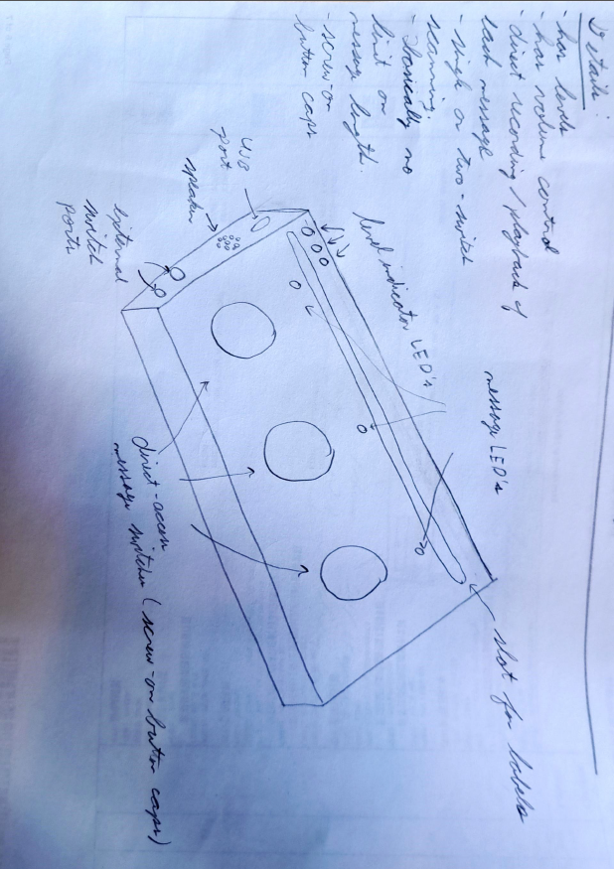

A cardboard mock-up was also created for this version of the device.

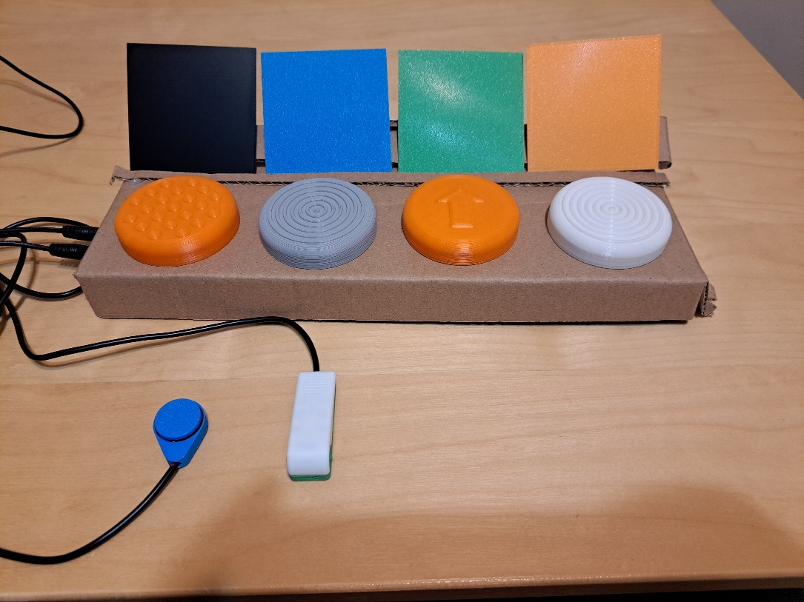

### Physical Component / Enclosure

Concept 2 would consist of a 3D printed enclosure to house the electrical components of the device. The enclosure would include a slot behind the direct access switches to allow caregivers/secondary users to place images behind the switches to represent the message that will be played. The direct access switch toppers would be designed so they could be switched easily (without the need of external fasteners). The ease of switching toppers would allow secondary users to replace toppers with ones that represent what each message played, or with textures to help users differentiate between the switches.

The enclosure would be 3D printed in multiple parts to make assembly and repair easier.

### Electrical Components

Concept 2 would include the electrical components from the Open Playback Recorder, with any additional components required for the differences in functions. These parts would include two three-position switches to change levels and playback speed, and custom PCBs to make assembly easier.

### Code Structure / Function

The code would function as outlined in flow diagram below.

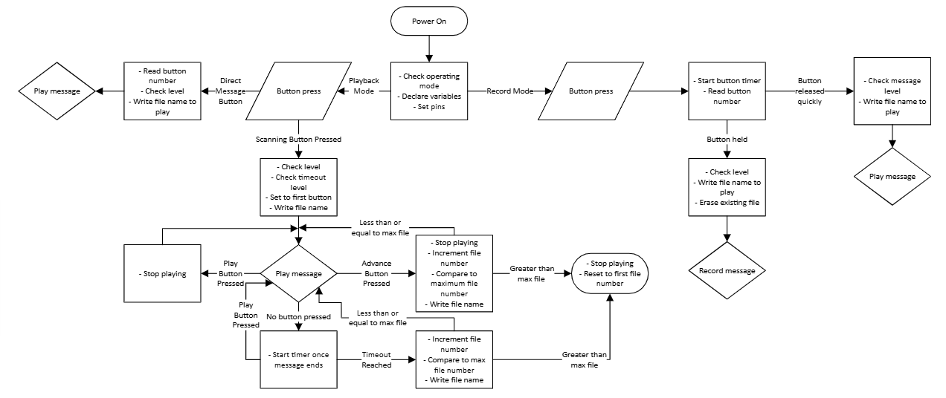

## Concept 3: Modified Open Playback Recorder – No Direct Message Access

A single or two-switch scanning device with auditory feedback to play pre-recorded messages.

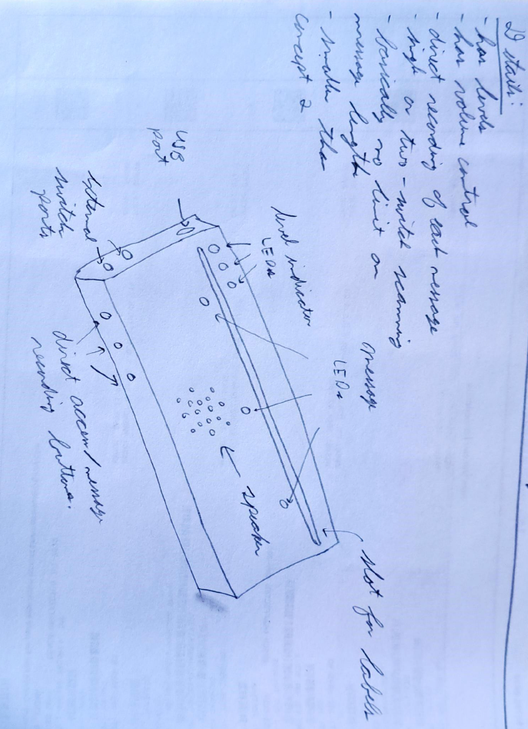

The cardboard mock-up for this design was the smallest, as it did not require space for integrated direct-access message.

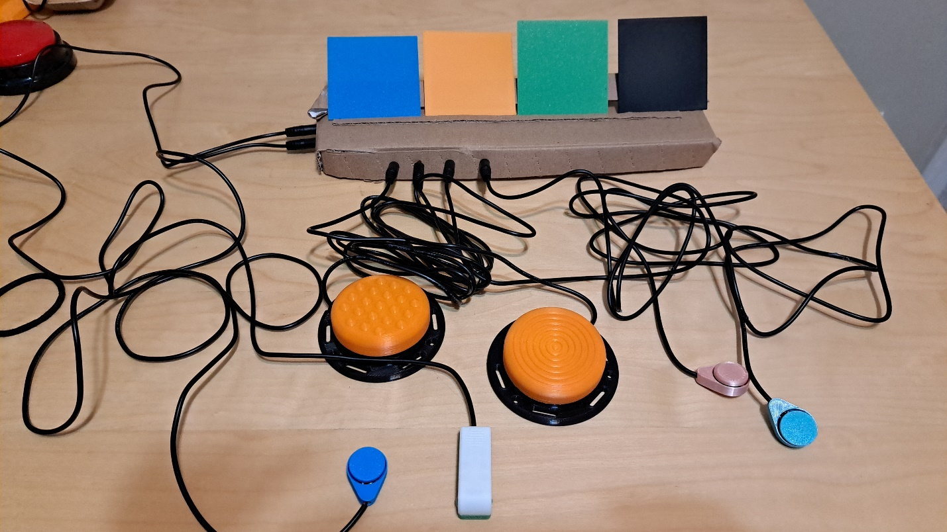

### Physical Component / Enclosure

This concept has the same general enclosure and physical components as Concept 2, but the user would require four additional assistive switches to access each message directly. These assistive switches would take the place of the four built-in switches in Concept 2.

### Electrical Components

This concept has the same general parts as Concept 2, except the switches required for the built-in switches.

### Code Structure / Function

The code would function exactly as the code in Concept 2.

## Concept Decisions

|  |  |  |
| --- | --- | --- |
| **Concept** | **Decision (Abandon, Modify, Proceed)** | **Justification** |
| Concept 1: Single Message Playback Switch Array | Abandon | The requestors needed levels and volume control as part of the design. |
| Concept 2: Modified Open Playback Recorder – Direct Messages Access | Proceed | The requestors thought this version best met their needs. |
| Concept 3: Modified Open Playback Recorder – No Direct Messages Access | Abandon | The requestors preferred having direct access to each message integrated with the device to focus it on teaching switch scanning. |

# Prototyping

Two prototypes were created: a solderless breadboard for testing the code and hardware, then a soldered protoboard version with a 3D printed enclosure. The soldered version with an enclosure was sent to two groups in Kingston, Ontario to test.

## Solderless Breadboard

The solderless breadboard prototype was used to build out the physical components and test the code of the Chatterbox. The solderless breadboard version started as the Open Playback Recorder schematic, and was modified throughout the prototyping process.

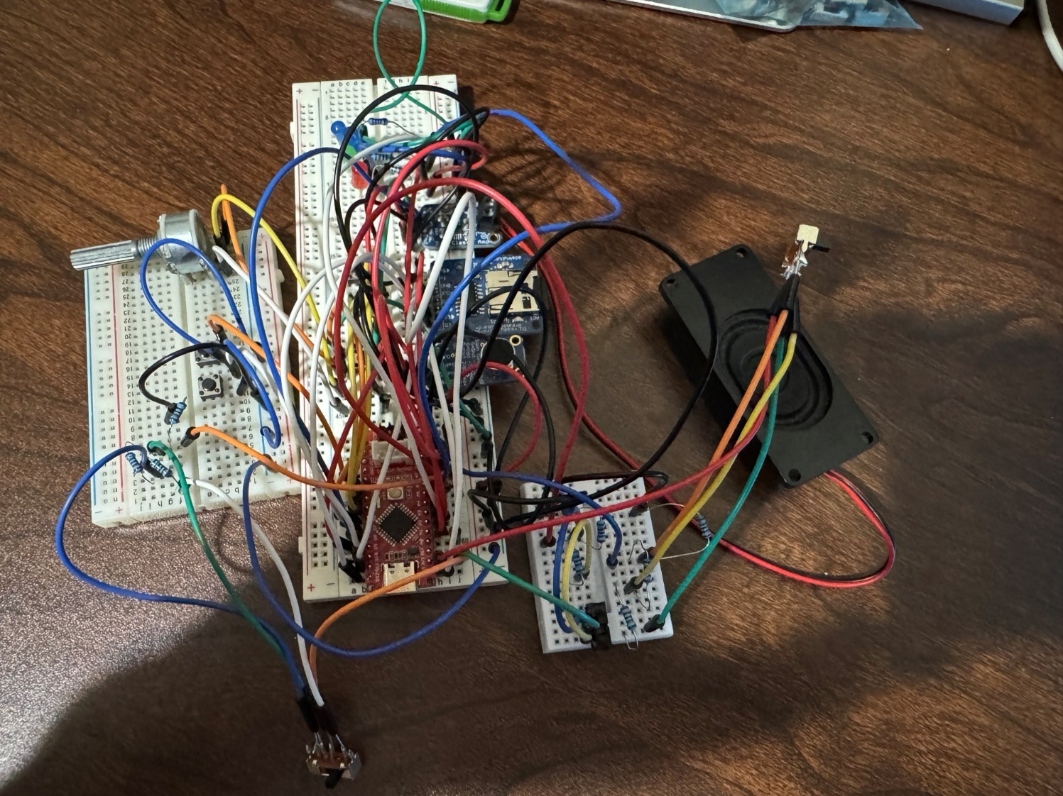

### Goals for this prototype:

The solderless breadboard prototype was meant to fully develop the code and the electronic components required for the Chatterbox. This prototype was meant to provide a proof of concept and function before putting in the time and resources to design a custom PCB.

The goals of the prototype were to:

* Test the audio recording and playback
* Develop and test the methods to change playback speed
* Develop and test the methods to change the message level
* Develop and test how users receive feedback from the device
* Develop and test the single switch scanning mode
* Develop and test the dual switch scanning mode
* Develop and test the method to record new messages

### Electrical Components

The electronic components in this prototype were mostly from the Open Playback Recorder, with a few added parts. The solderless breadboards and jumper wires were not included in the list of parts below.

|  |  |  |  |
| --- | --- | --- | --- |
| Part | Quantity | Cost (CAD) | Link |
| Seeeduino Nano | 1 | $7.60 | <https://www.digikey.ca/en/products/detail/seeed-technology-co-ltd/102010268/10290292> |
| 5V ready micro SD breakout board | 1 | $7.50 | <https://www.digikey.ca/en/products/detail/adafruit-industries-llc/254/5761230> |
| 2.5W Class D amp | 1 | $3.95 | <https://www.digikey.ca/en/products/detail/adafruit-industries-llc/2130/5761279> |
| 2.2 kOhm resistor | 12 | $1.20 ($0.10 each) | [MFR-25FRF52-2K2 YAGEO | Resistors | DigiKey](https://www.digikey.ca/en/products/detail/yageo/MFR-25FRF52-2K2/13921897?gclsrc=aw.ds&gad_source=1&gad_campaignid=17336435733&gclid=EAIaIQobChMI5OTovaWDjwMVjSzUAR0M4S9WEAQYASABEgJ-afD_BwE) |
| 5mm LED | 4 | $0.96 ($0.24 each) | [151051BS04000 Würth Elektronik | Optoelectronics | DigiKey](https://www.digikey.ca/en/products/detail/w%C3%BCrth-elektronik/151051BS04000/4490009) |
| Mono speaker | 1 | $3.95 | [3351 Adafruit Industries LLC | Audio Products | DigiKey](https://www.digikey.ca/en/products/detail/adafruit-industries-llc/3351/6612456) |
| Potentiometer | 1 | $1.82 | [PTN16-A10125K1A2 Same Sky (Formerly CUI Devices) | Potentiometers, Variable Resistors | DigiKey](https://www.digikey.ca/en/products/detail/cui-devices/PTN16-A10125K1A2/20380750) |
| Micro SD card | 1 | $4.95 | [5252 Adafruit Industries LLC | Memory - Modules, Cards | DigiKey](https://www.digikey.ca/en/products/detail/adafruit-industries-llc/5252/15841478) |
| Microphone | 1 | $7.95 | [1713 Adafruit Industries LLC | Development Boards, Kits, Programmers | DigiKey](https://www.digikey.ca/en/products/detail/adafruit-industries-llc/1713/4990777) |
| Tactile switch | 6 | $1.62 ($0.27 each) | [B3F-4050 Omron Electronics Inc-EMC Div | Switches | DigiKey](https://www.digikey.ca/en/products/detail/omron-electronics-inc-emc-div/B3F-4050/95200) |
| 3 position slide switch | 2 | $2.42 ($1.21 each) | [OS103011MA7QP1 C&K | Switches | DigiKey](https://www.digikey.ca/en/products/detail/c-k/OS103011MA7QP1/1981432) |
| 2 position slide switch | 2 | $1.90 ($0.95 each) | [OS102011MA1QS1 C&K | Switches | DigiKey](https://www.digikey.ca/en/products/detail/c-k/OS102011MA1QS1/1981431) |

### Code Structure / Function

The code for this prototype is built off the code for the [Open Playback Recorder](https://github.com/makersmakingchange/Open-Playback-Recorder). The general code structure is outlined in this section.

#### Startup

* Check if in playback or record mode
  + Check the voltage on a pin (either pulled up or pulled down, depending on position of a three-position switch)
* Playback mode
  + All message LEDs are off unless message is being played
  + Wait for direct access switch to be pressed, or switch scanning to be started
    - If direct access switch pressed
      * Read message number based on switch number (pin pressed)
      * Check level
        + Level is controlled by voltage reading on a three-position switch and resistor ladder
      * Play corresponding message function
    - If switch scanning started
      * Check level
      * Light corresponding LED while message is playing
      * Play message in position 1
      * Check delay time
        + Delay time is controlled by voltage reading on a three-position switch and resistor ladder
        + Wait for delay time
      * If selection switch is not pressed during delay time, advance message and repeat
      * If selection switch is pressed at any time during delay or message playing
        + Replay current message
        + Exit switch scanning
      * If advance message switch is pressed at any time during playback
        + Stop playback
        + Advance to next message
        + Play next message
        + If advancing past the last message, start at first message again
      * If last message is reached and delay times out without any advance or selection
        + Exit switch scanning
* Record mode
  + Blink lights on all messages while no message is being recorded
  + Wait for direct access switch to be held
    - Stop blinking all lights
    - Read message number based on switch number (pin pressed)
    - Check level
    - Erase existing corresponding message
    - light on corresponding message when ready to record message (and while recording)
    - Record message while switch is being held
    - Stop recording when switch is released
    - Start blinking all four message lights again
  + Direct access switch is pressed, but no held
    - Stop blinking all lights
    - Read message number based on switch number (pin pressed)
    - Check level
    - Turn on corresponding LED
    - Play recorded message
    - Start blinking all four message lights again
  + Exit record mode

#### Functions

##### Check level

Level is controlled via analogue reading on a single pin connected to a three-position switch and a resistor network. The position of the switch will change the voltage reading on that single pin.

* Read the voltage on the analogue pin
* Compare voltage to two threshold values
  + If above top threshold, level 1
  + If between thresholds, level 2
  + If below lowest threshold, level 3

##### Check delay

The delay between messages ending and advancing to the next message is controlled in the same way as the level, using the same resistor network but a different three-position switch.

* Read the voltage on the analogue pin
* Compare voltage to two threshold values
  + If above top threshold, fast
  + If between thresholds, medium
  + If below lowest threshold, slow

The delays for slow, medium, and fast, were chosen as 20 seconds, 15 seconds, and 10 seconds. These values are currently arbitrarily chosen but will be changed based on user feedback. There will also be instructions to change these delays in the code if a user/clinic decides they would like custom speeds.

##### Play message

The change to this function from the Open Playback Recorder will be that the message number does not update when the message plays, but is controlled by the end of the delay, or pressing the advance button switch. Additionally, the LED for the corresponding message will be on while playing

* Check level
* Read message number
* Turn on corresponding LED
* Play message
* Stop message playing

##### Record message

The record message function changes from the Open Playback Recorder with the introduction of direct message access. The messages on the level won’t all be deleted when entering record mode, but instead will be deleted individually when a new message is about to be recorded.

* Read the message being recorded
* Stop flashing all message lights
* Check the level
* Delete corresponding existing message
* Flash corresponding message LED
* Record message while switch is held
* Start flashing all message LEDs when message has been saved and ready to record new message

##### Switch scanning

The switch scanning function is only available in playback mode. The switch scanning is set for automatic switch scanning, where the user presses a switch to start scanning and select messages. Messages advance based on a pre-set delay period after the message has been played (as explained in the Check delay function). If a user has a second switch and would like to do dual switch scanning, a second switch can be used to advance to the next message at any time; however, the delay will still be in effect. If a user is dual switch scanning but does not select to replay or advance the message before the delay expires, the next message will play.

* Selection switch is pressed to initiate scanning
* Set message number as first message
* Play message function
* Wait for delay
* If no other input and delay expires
  + Turn off corresponding LED
  + Advance message number
  + Play next message
* If message is selected
  + Play message function again
* If advance message switch is pressed
  + Stop playing message
  + Advance message number
  + Check if message number is beyond number of messages
    - If beyond number of messages
      * Restart at first message
  + Play message function
* If last message is reached and delay expires on it without additional input
  + End message scanning

#### Arduino Libraries

The following Arduino libraries were used in the prototype. The purpose of each library is included in the table.

|  |  |  |
| --- | --- | --- |
| Library | Author | Purpose |
| [TMRpcm](https://github.com/TMRh20/TMRpcm) | TMRh20 | Handles recording and playback of messages. |
| SD | Arduino | Handles interactions with the SD card. |
| SPI | Arduino | Handles communication with serial peripheral interface (SPI) devices. |
| [StateMachine](https://github.com/jrullan/StateMachine) | jrullan | Allows for simple implementation of a state machine. |
| [neotimer](https://github.com/jrullan/neotimer) | jrullan | Allows for integrated timing with the state machine library. |

### Function and number of pins

The table below summarizes the function and pin type required for each part of the code.

|  |  |  |
| --- | --- | --- |
| Function | Number of pins | Type of pins |
| Button 1 LED | 1 | Analog or digital output |
| Button 2 LED | 1 | Analog or digital output |
| Button 3 LED | 1 | Analog or digital output |
| Button 4 LED | 1 | Analog or digital output |
| On/Off LED | 1 | Analog or digital output |
| Button 1 switch | 1 | Digital input |
| Button 2 switch | 1 | Digital input |
| Button 3 switch | 1 | Digital input |
| Button 4 switch | 1 | Digital input |
| Scanning switch jack | 1 | Digital input |
| Selecting switch jack | 1 | Digital input |
| Level selection (resistor array) | 1 | Analog input |
| Amp | 1 | Digital output |
| SD reader | 4 | Digital I/O |
| Microphone | 1 | Analog I/O |
| Audio potentiometer | 1 | Digital output |
| Record vs play state | 1 | Digital I/O |

The total number of pins in this setup is 20.

### Microcontroller and peripherals comparison

The microcontroller inherited from the Open Playback Recorder was near its memory limit for the Open Playback Recorder, so other options were investigated. These options also included shields, which could simplify the circuitry and potentially decrease cost. The different microcontroller and peripherals comparisons are summarized in the following tables. To simplify the tables, common parts among the different options (such as the speaker and microphone) are excluded.

|  |  |  |
| --- | --- | --- |
| Seeeduino Nano and breakout boards (from Open Playback Recorder) | | |
| Part | Cost (CAD) | Link |
| Seeeduino Nano | $7.60 | <https://www.digikey.ca/en/products/detail/seeed-technology-co-ltd/102010268/10290292> |
| 5V ready micro SD breakout board | $7.50 | <https://www.digikey.ca/en/products/detail/adafruit-industries-llc/254/5761230> |
| 2.5W Class D amp | $3.95 | <https://www.digikey.ca/en/products/detail/adafruit-industries-llc/2130/5761279> |

Note that the Feather boards are designed to be powered via USB or LiPoly batteries, not other methods like 9V batteries. A USB charger was added to the cost for these options to reflect this.

|  |  |  |
| --- | --- | --- |
| Adafruit Feather and Music Wing | | |
| Part | Cost (CAD) | Link |
| Adafruit Feather RP2040 | $11.95 | <https://www.digikey.ca/en/products/detail/adafruit-industries-llc/4884/14000603> |
| Music Maker FeatherWing with amp | $24.95 | <https://www.digikey.ca/en/products/detail/adafruit-industries-llc/3436/6827175> |
| USB charger | $14.95 | <https://www.adafruit.com/product/1959> |

|  |  |  |
| --- | --- | --- |
| Adafruit Feather only | | |
| Part | Cost (CAD) | Link |
| Adafruit Feather RP2040 Adalogger | $14.95 | <https://www.digikey.ca/en/products/detail/adafruit-industries-llc/5980/24639131> |
| 2.5W class D amp | $3.95 | <https://www.digikey.ca/en/products/detail/adafruit-industries-llc/2130/5761279> |
| USB charger | $14.95 | <https://www.adafruit.com/product/1959> |

|  |  |  |
| --- | --- | --- |
| Adafruit ItsyBitsy M0 Express | | |
| Part | Cost (CAD) | Link |
| Adafruit ItsyBitsy M0 Express | $11.95 | <https://www.digikey.ca/en/products/detail/adafruit-industries-llc/3727/8346575> |
| 5V ready micro SD breakout board | $7.50 | <https://www.digikey.ca/en/products/detail/adafruit-industries-llc/254/5761230> |
| 2.5W Class D amp | $3.95 | <https://www.digikey.ca/en/products/detail/adafruit-industries-llc/2130/5761279> |

Based on the increased cost and complexity of changing the microcontroller, we decided to continue using the Seeeduino Nano. The code had to be optimized to reduce memory usage due to the memory limitations of the Nano’s microchip.

### Memory usage optimization

Message playback was affected by memory limitations on the microchip. Once a certain memory threshold was reached (the exact value was not determined), the device would no longer play back messages. The device treated each message as if it were a very short recording without any sound, but functioned as expected otherwise. It was initially unclear what was causing the issues, but after testing other potential causes, it was determined that memory was the cause.

Most of the memory optimization came from changing the format of the debugging serial information. Initially, set character strings (such as labels and explanations) were written as:

Serial.print(“Example debug message”);

Formatting these strings differently drastically reduced memory usage. The new format is as follows:

Serial.print(F(“Example debug message”));

Additionally, creating a flags structure for Boolean operators that act as flags in the code reduced memory usage. Originally, flags were individual Boolean variables, written as:

bool flag_1;

bool flag_2;

These operators could be rewritten in a structure as:

struct Flags {

bool flag_1 : 1;

bool flag_2 : 1;};

Flags flags;

To call a flag from this structure, such as flag_1, you would write flags.flag_1.

## Soldered Protoboard

The soldered protoboard prototype was created to get feedback on the device before ordering custom PCBs. It was delivered to OTs in Kingston, Ontario, who tested it with clients and by themselves.

### Physical Component / Enclosure

The soldered protoboard prototype had a full 3D printed enclosure that resembled Concept 2. The enclosure was too large to fit on regular 3D printer build plates, so it was printed in quarters, and assembled after printing. The fully assembled prototype can be seen below.

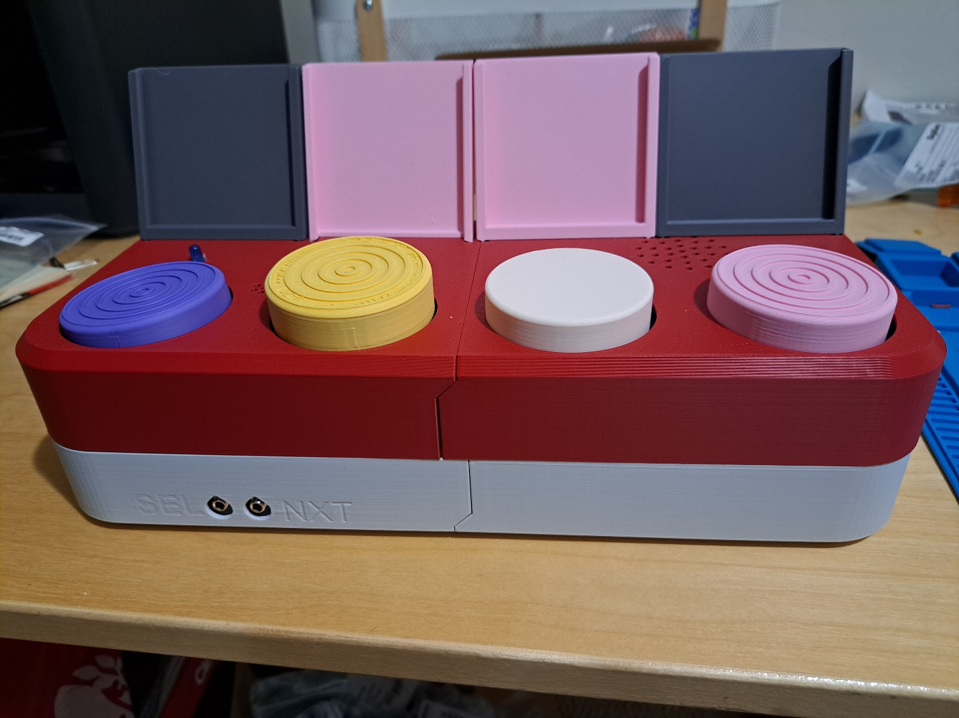

The two parts of the top and bottom halves of the enclosure were connected using screws initially. To facilitate printing and to allow the screws to connect both parts, the screw posts were split at an angle, as shown in the cross-section below.

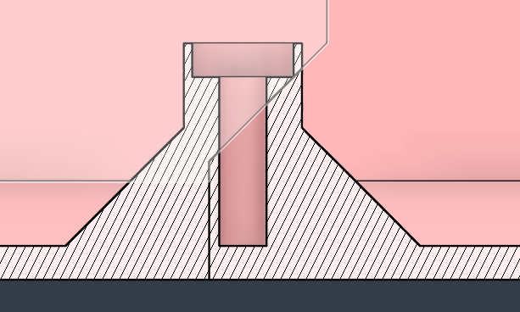

This method did not work as well as hoped. It was difficult to screw the parts together without introducing a noticeable gap, as can be seen on the top half of the enclosure. The connection was also not as strong as hoped, and allowed for flexion and separation in the parts.

The front of the enclosure has two labeled ports for the assistive switches used for single or dual switch scanning. The four buttons on top of the device are for direct access to individual messages, and the toppers can be twisted on and off by hand. There are four holders for images that correspond to the messages on each button, and LEDs that light up for visual feedback. There are also holes on top for sound to enter and escape for the microphone and speaker, respectively.

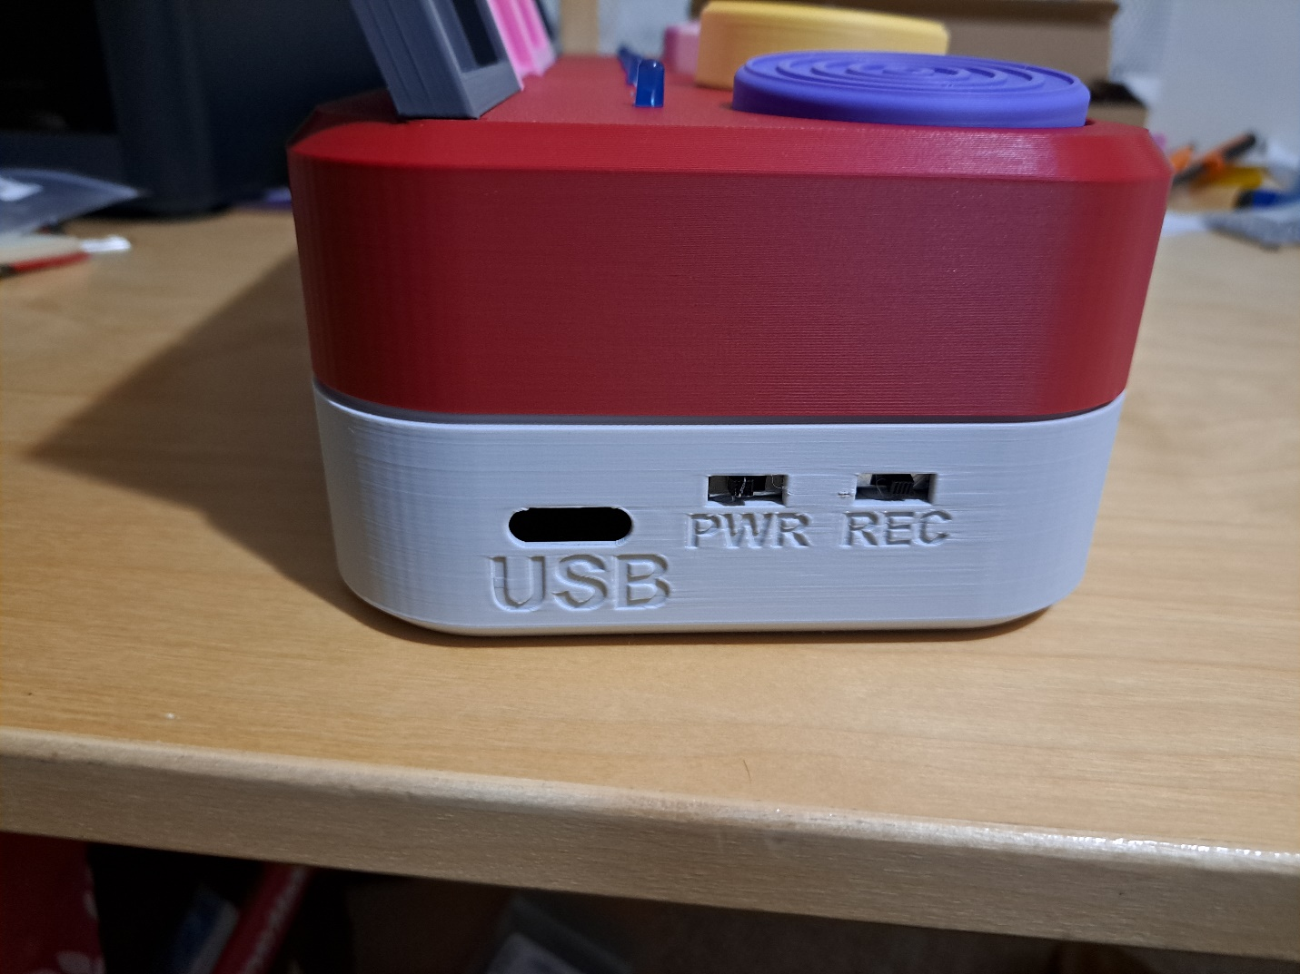

The side view of the enclosure shows the port for the USB to connect to the microcontroller, and the power and mode switches. The mode switch changes between recording and playback, and the power turns the device on and off. The USB port can be used to updated firmware, or power the device off the USB.

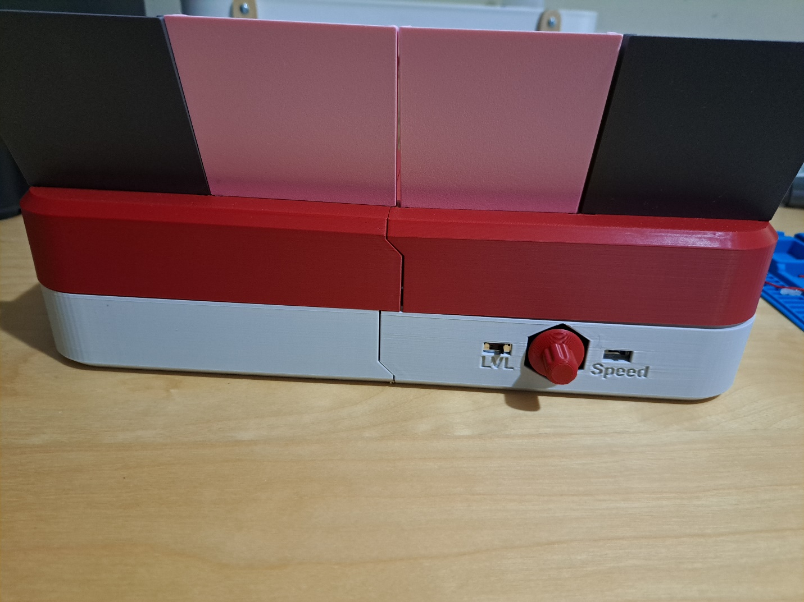

The volume is adjusted at the back of the enclosure with the red knob, and the level and delay timing (Speed) are adjusted with the three-position switches on either side of the knob.

#### Button Bases

To make parts simpler to print and handle, and to make it easier to replace broken parts, the button bases that hold the tactile switches for direct message access were designed to be printed separately from the enclosure. The bases connect to the enclosure with snap fits. The snap fits are based on the ideas from [Slant 3D](https://www.youtube.com/watch?v=RTQjvYENR7w). These snap fits were used throughout the design to connect parts without the need of other fasteners.

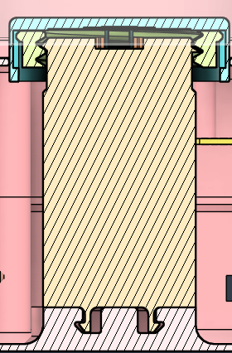

The bases are also flat on one side to make printing easier, and give space for the wires from the tactile switches to clear the caps.

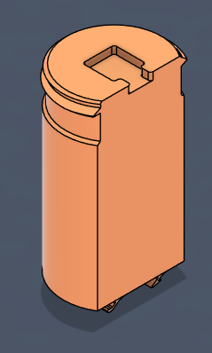

#### Swappable button caps

The button caps were designed to be easily swappable without the need for tools. These are based on the [Switched Adapted Toys 3D Printed Switch](https://www.switchedtoys.org/pages/3d-printed-switch-button). The button cap insert (yellow in the figure) has the threads to twist onto the base, and the cap (in teal) can slide freely up and down on the insert.

A change to their design was to stop the threads and have a smooth section of base the insert can slide and spin on. The intention of this section is to prevent over-tightening that could break the parts, or cause a switch to be permanently pressed.

### Electrical Components

This prototype consisted mostly of the same electrical components as the solderless breadboard prototype, but had a few extra components, listed below.

|  |  |  |  |
| --- | --- | --- | --- |
| Part | Quantity | Cost (CAD) | Link |
| 9V battery clip | 1 | $0.59 | [232 Keystone Electronics | Battery Products | DigiKey](https://www.digikey.ca/en/products/detail/keystone-electronics/232/303804) |
| Mono jacks | 2 | $3.00 ($1.50 each) | [MJ-3502 Same Sky (Formerly CUI Devices) | Connectors, Interconnects | DigiKey](https://www.digikey.ca/en/products/detail/same-sky-formerly-cui-devices/MJ-3502/281321) |
| General purpose protoboard | 1 | $7.02 | [12070 SparkFun Electronics | Prototyping, Fabrication Products | DigiKey](https://www.digikey.ca/en/products/detail/sparkfun-electronics/12070/5230951) |
| 40x60mm protoboard | 1 | $2.50 | [4785 Adafruit Industries LLC | Prototyping, Fabrication Products | DigiKey](https://www.digikey.ca/en/products/detail/adafruit-industries-llc/4785/13617529?s=N4IgjCBcoCwGxVAYygMwIYBsDOBTANCAPZQDaIMAHAKwDsMMIAuoQA4AuUIAyuwE4BLAHYBzEAF9xhAExkQAIz650AE3lF0fFc3FA) |

### Code Structure / Function

The code developed on the solderless breadboard was added to this prototype, with one major change: rather than using a three-position switch to move between ON-OFF-RECORD, the ON-OFF is controlled by a single two-position switch, and the mode is controlled by another. The mode is controlled by the voltage reading from a resistor ladder attached to the Mode switch.

## Printed Circuit Board (PCB) Prototype

The PCB prototype is essentially the same as the soldered protoboard prototype. There are minor changes to the position of switches and jacks, but the main difference is the use of custom PCBs to make assembly easier.



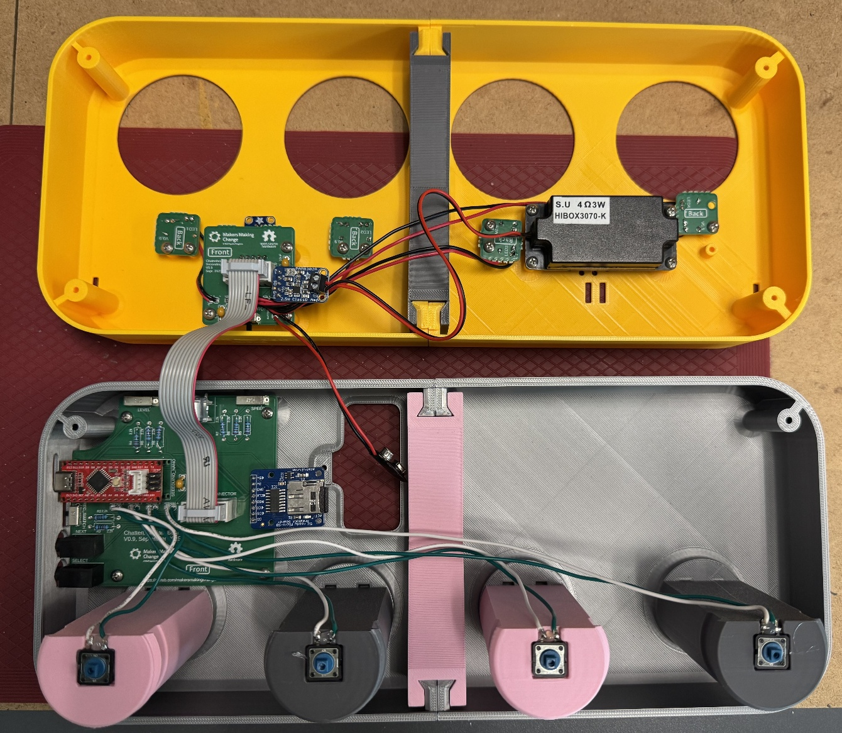

### Physical Components / Enclosure

Most of the physical components received only minor changes, such as the location of the switches and switch ports; however, some parts had major changes.

#### Connecting top and bottom quarters to each other

The top and bottom quarters are connected to each other using a snap fit, like those in the button bases, and another 3D printed part to add rigidity (the centre support).

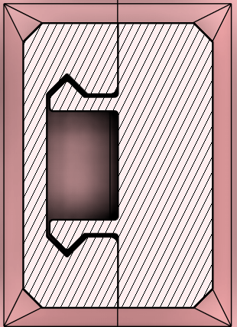

The snap fits were sized so that the top quarters cannot snap together with the bottom quarters. The different sizes prevent mistakes while assembling the enclosure.

The centre support slides over a dovetail and holds the quarters of the top and bottom halves together more firmly than with the snap fits alone. The support also adds strength and rigidity across the centre of the enclosure, which was lacking in the soldered breadboard prototype.

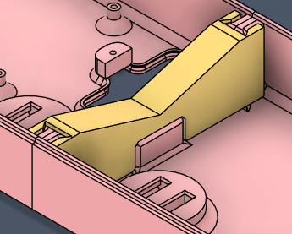

#### Battery Cover

A battery cover design from the Open Playback Recorder was added to more securely hold the 9V battery, and to make it easier to replace the battery if it dies.

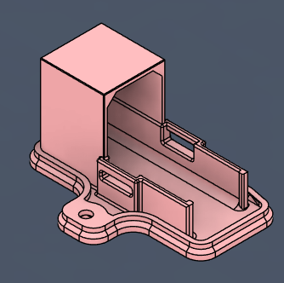

### Electronic Components

The major change the to the electronic components was to add the custom PCBs. Due to size limits from most PCB manufacturers, the board was split into two designs: the Main PCB, and the Secondary PCB. The Secondary PCB also had breakaway smaller PCBs for each of the LEDs.

The schematics for all PCBs can be found in the Detailed Design section.

#### Main PCB

The Main PCB was named so because it is the larger board with more of the electrical components. The Main PCB is mounted to the bottom half of the enclosure, with the switches and volume knob sticking out the side to be accessible.

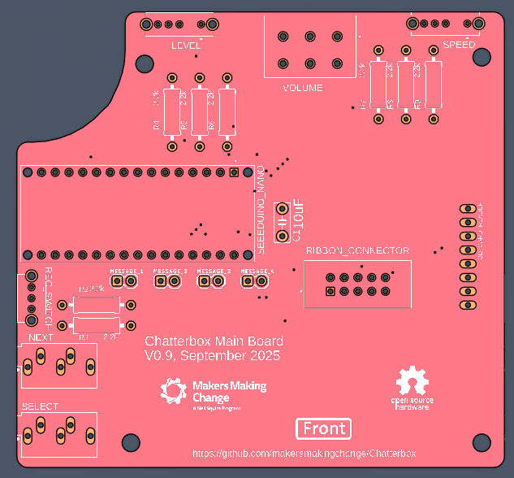 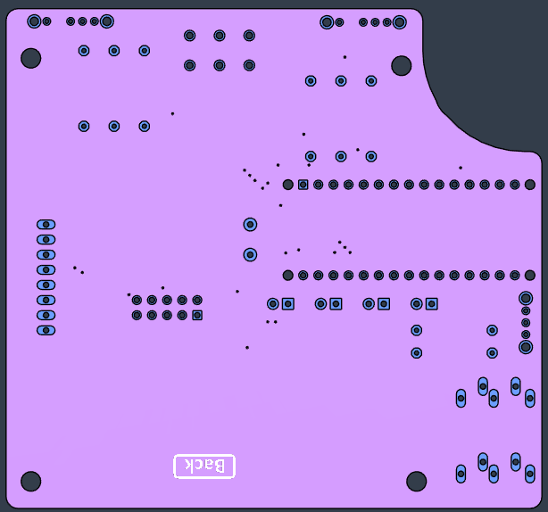

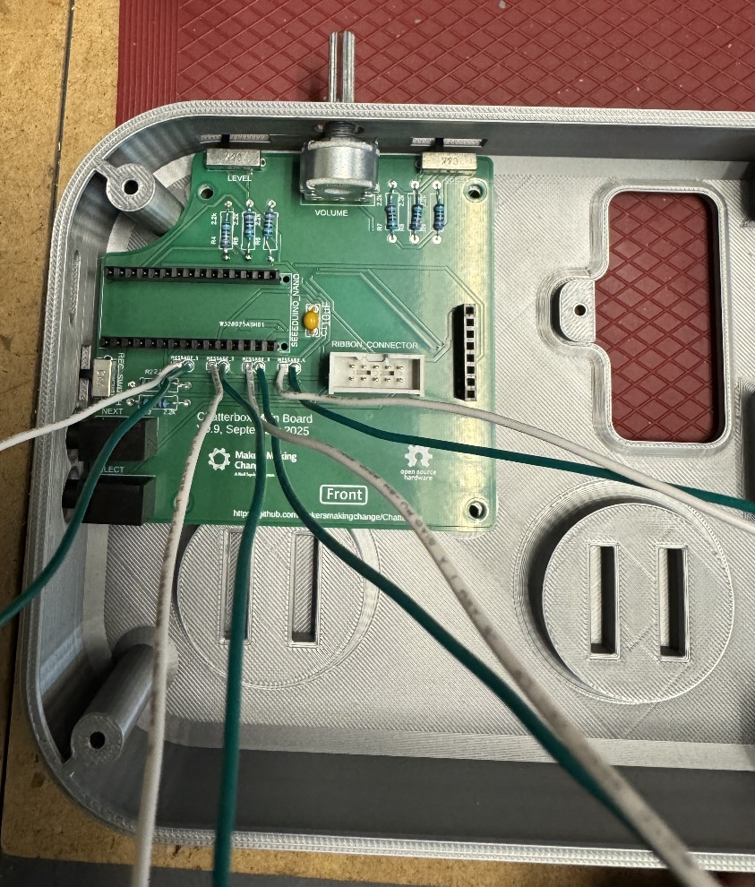

#### Secondary PCB

The Secondary PCB was named so as it is the smaller of the two boards and does not have the microcontroller. It was originally designed to be made with the four LED boards as part of it, connected by mouse bites which could be broken off by the maker. The goal of this PCB panelization was to reduce cost and complexity of the build.

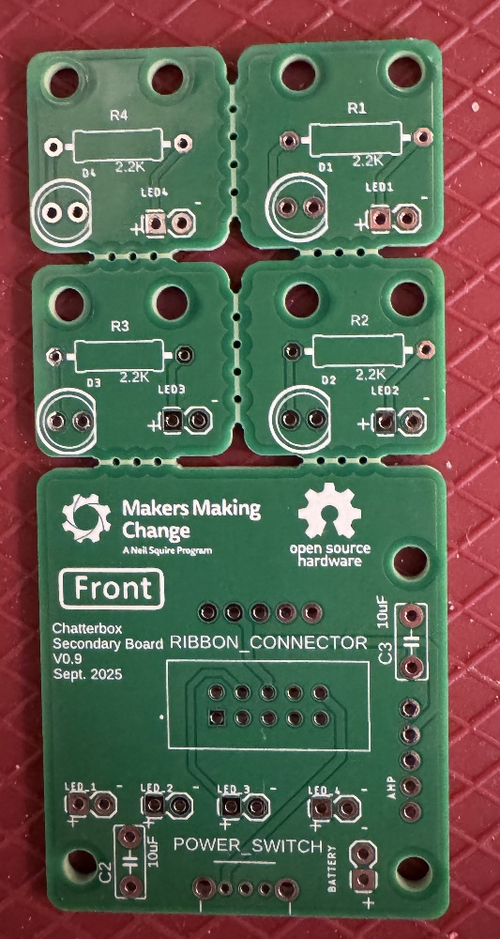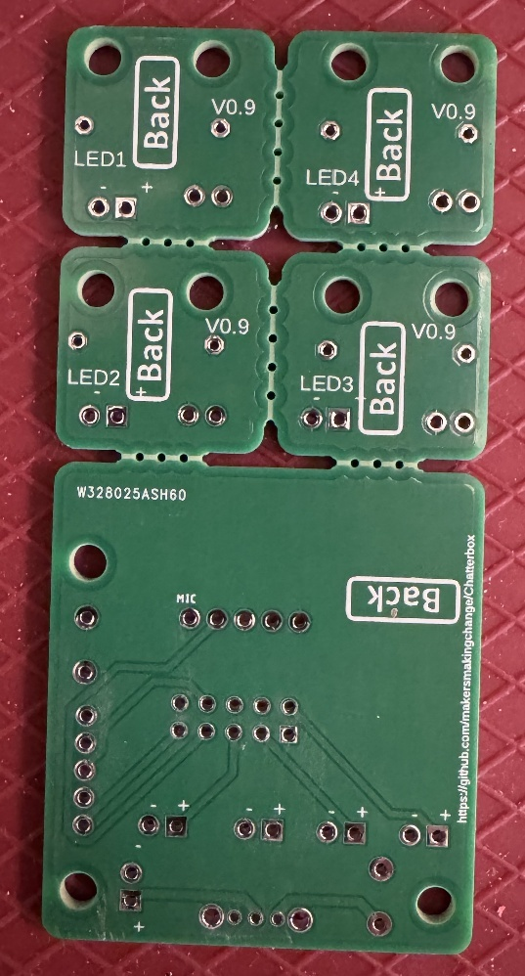

#### LED PCBs

The LED PCBs were named so because they were made to more consistently connect and position the LEDs and their resistors. They were made to be broken off the Secondary PCB. The mouse bites were more difficult to break than expected, and they drastically increased the cost of ordering the PCBs. PCBWay treated the Secondary board as five PCB designs on one board, making them $75 to order.

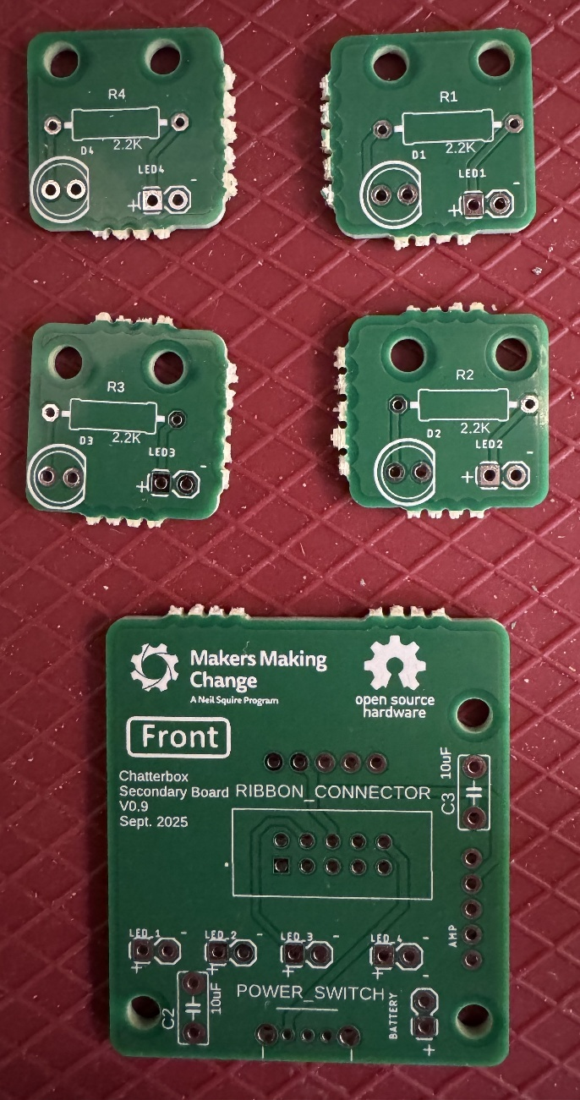

## Prototype Decisions

|  |  |  |
| --- | --- | --- |
| **Prototype** | **Decision (Abandon, Modify, Proceed)** | **Justification** |
| Solderless breadboard | Modify | Created to easily test code and hardware, but not useful for a final device. |
| Soldered Protoboard | Modify | The increased cost and design work to create PCBs is warranted by the complexity of assembling the soldered protoboard version. |
| PCB Prototype | Modify | The panelized PCB for the LEDs and Secondary board were much more expensive than ordering them separately, so needed to be separated. |

# Testing

Verification tests were completed throughout the project, and should be repeated when there are changes to components of the device (when appropriate). The tests, methods, and results can be found in the Verification Section and Appendices of the Design Rationale.

# Detailed Design

## Overview

The Chatterbox is a switch scanning communication device which provides auditory feedback to guide the user while scanning. 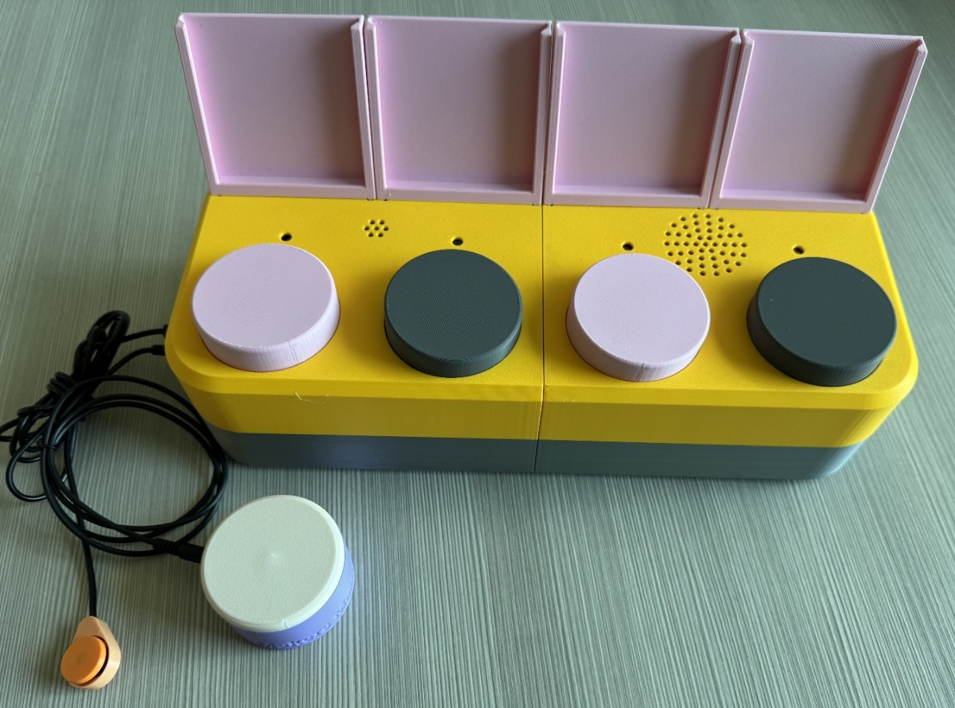

Figure 1: Assembled Chatterbox with assistive switches.

Some key information is highlighted in the table below.

Table 1: TODO: figure out what to call this table

|  |  |
| --- | --- |
|  |  |
| Cost | $136.00 (CAD) |
| Dimensions (mm) | 330 x 140 x 80 (main enclosure body only) 330 x 156 x 150 (including label holders and volume knob) |
| Mass (g) | 884 |
| Number of 3D printed parts | 24 (11 unique parts) |
| Mass of 3D printed parts (g) | 707 |
| Print Time | 20 hours, 10 minutes |
| Assembly Time | 1 hour |

The Chatterbox is divided into the following systems:

* Enclosure
* Direct access buttons
* Electrical components
* Firmware

Each subsystem and the key design decisions are summarized in this section.

### Enclosure

The enclosure can be further broken down into its own subsystems:

* Enclosure body
* Centre supports
* Label Holders
* Battery cover
* Volume knob

#### Enclosure Body

The enclosure body was split into four parts so that the Chatterbox could be printed on most commercially available FDM printers. The 330 mm length is too long to fit in a standard printer workspace, which is typically around 250x250x250 mm. The bottom quarters and top quarters connect to each other by a snap fit to reduce the number of required screws and make assembly/disassembly easier. The snap fit is based on those shown in [a video by Slant 3D.](https://www.youtube.com/watch?v=RTQjvYENR7w) The top quarters are incompatible with the bottom quarters, so a maker cannot connect the wrong parts together.

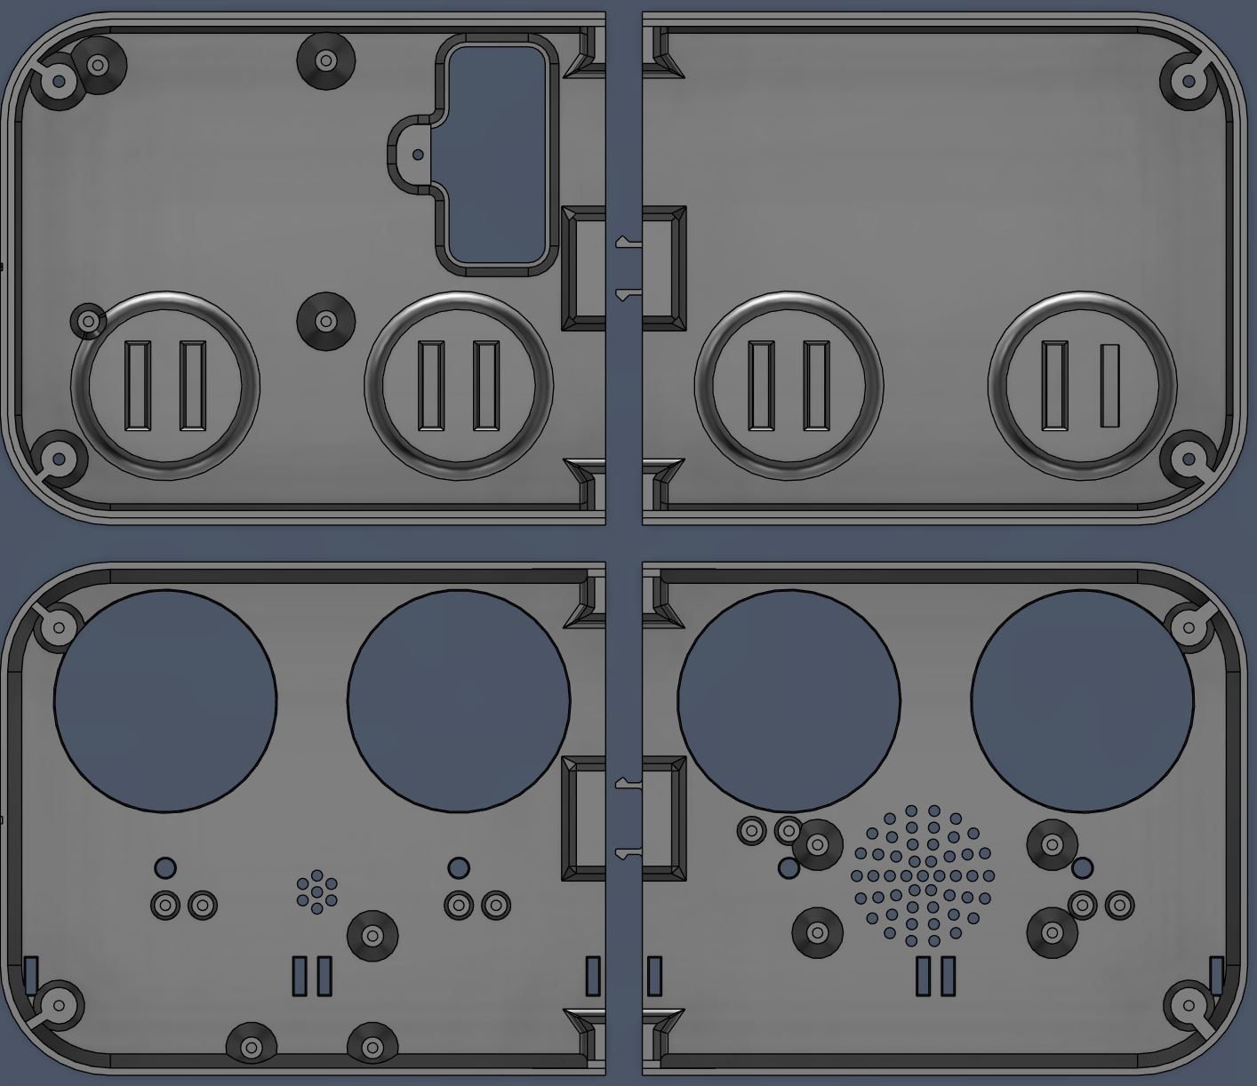

Figure 2: View of the inside of each of the four quarters of the Chatterbox.

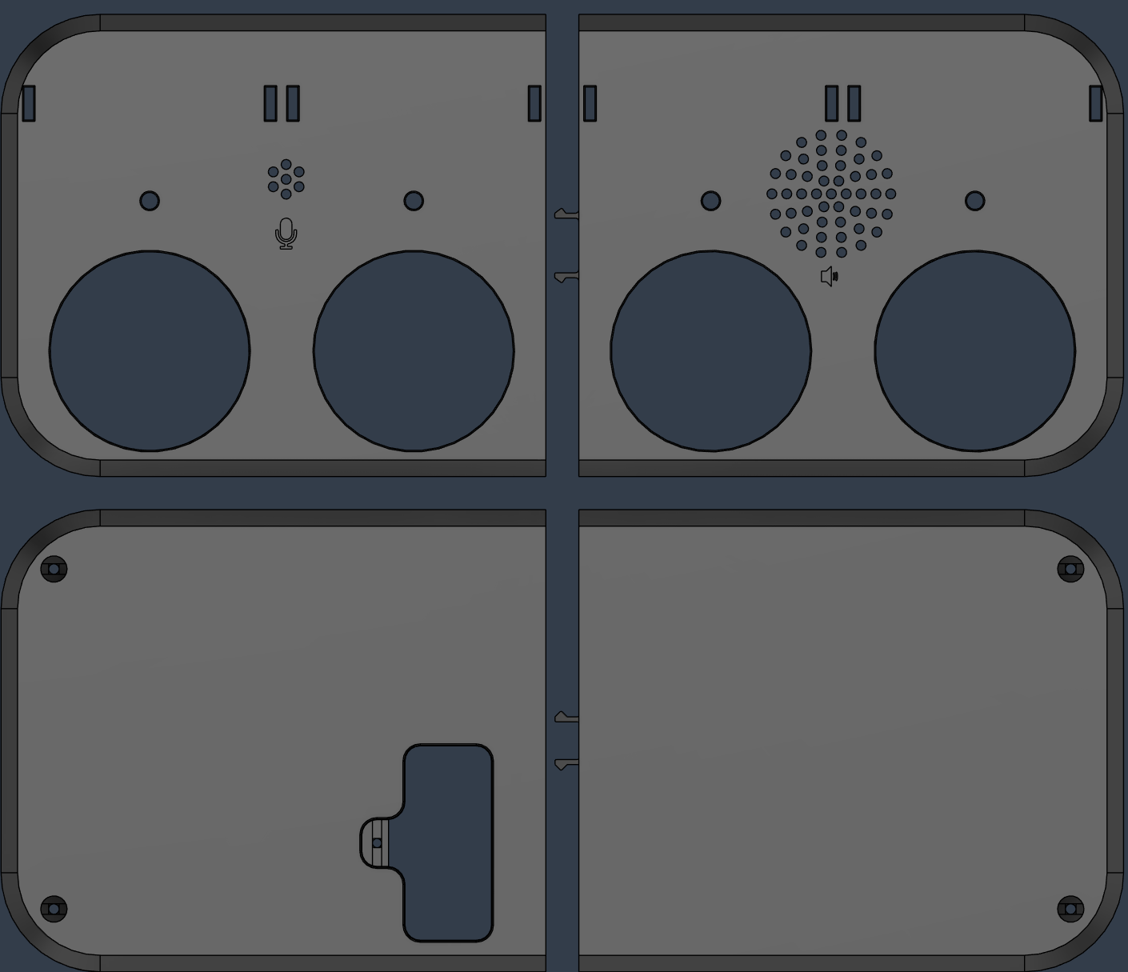

Figure 3: View of the outside of each of the four quarters of the Chatterbox.\

All ports and access points on the sides and back of the enclosure are labelled with their respective functions. Slide switches have labelling to show what each position does (ex: Record vs Playback mode, Off vs On). Due to size and positioning constraints of the PCB, some of the labelling is somewhat cluttered on the side of the enclosure.

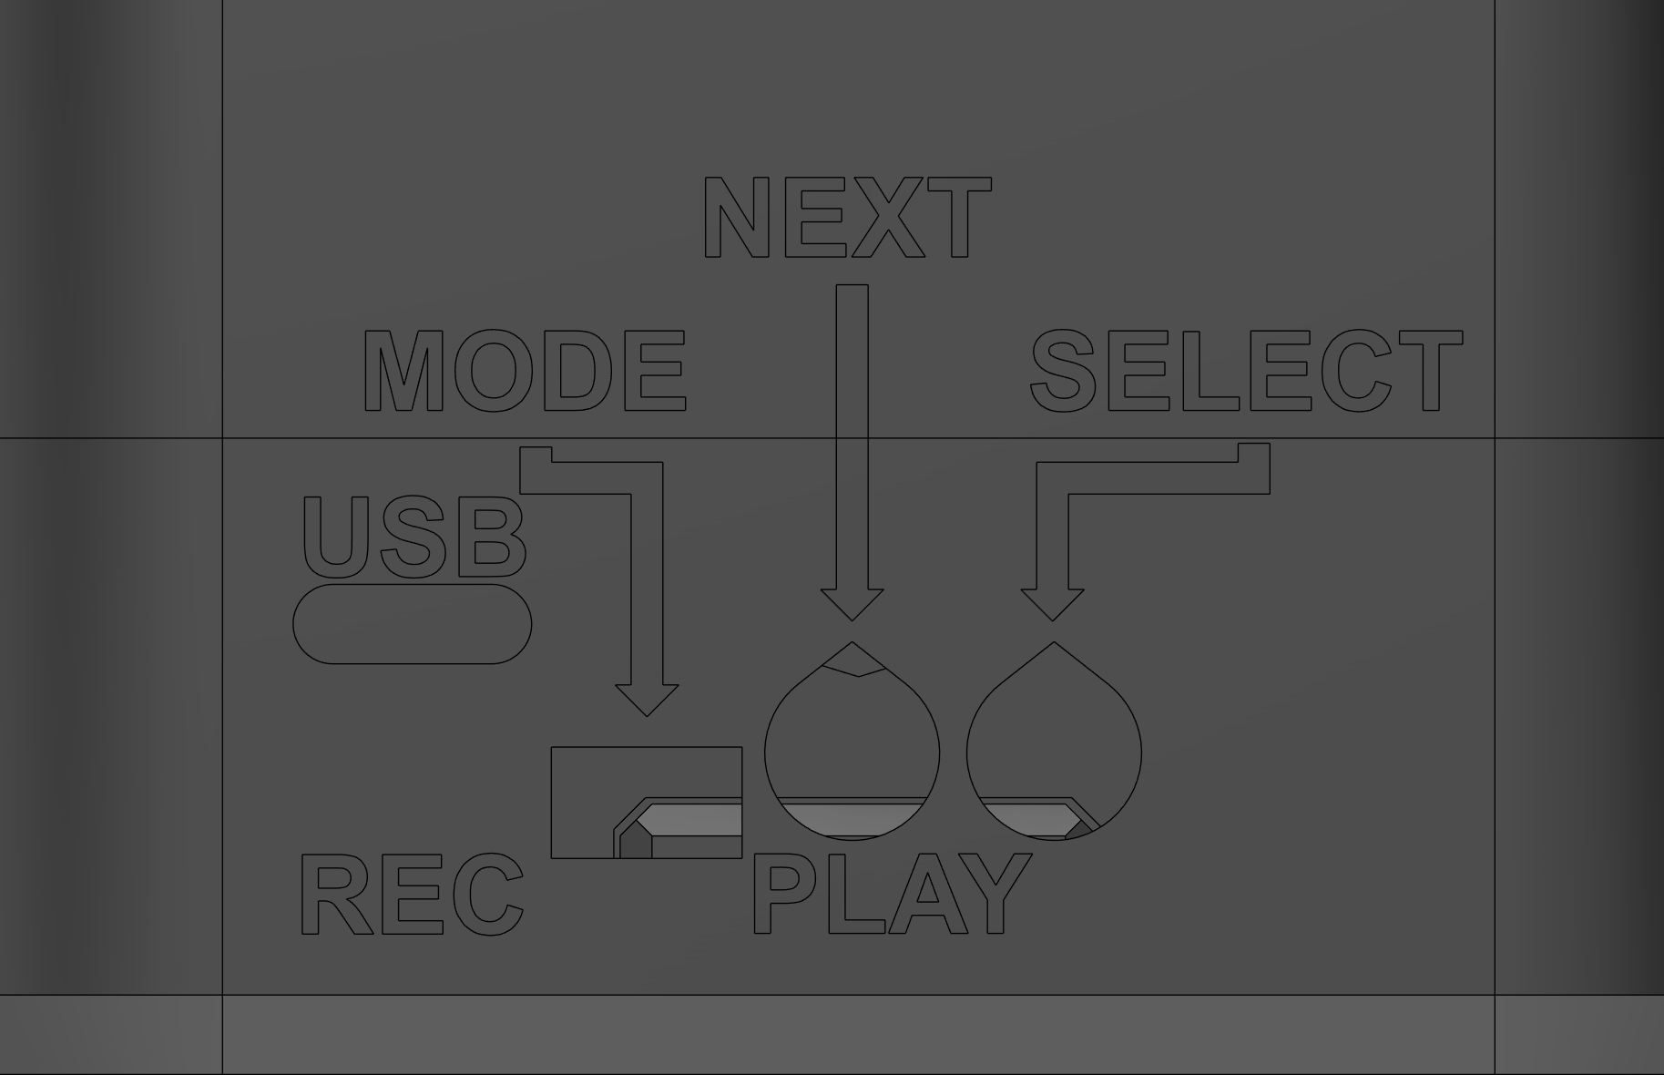

Figure 4: Screenshot of the labels on the side of the Chatterbox.

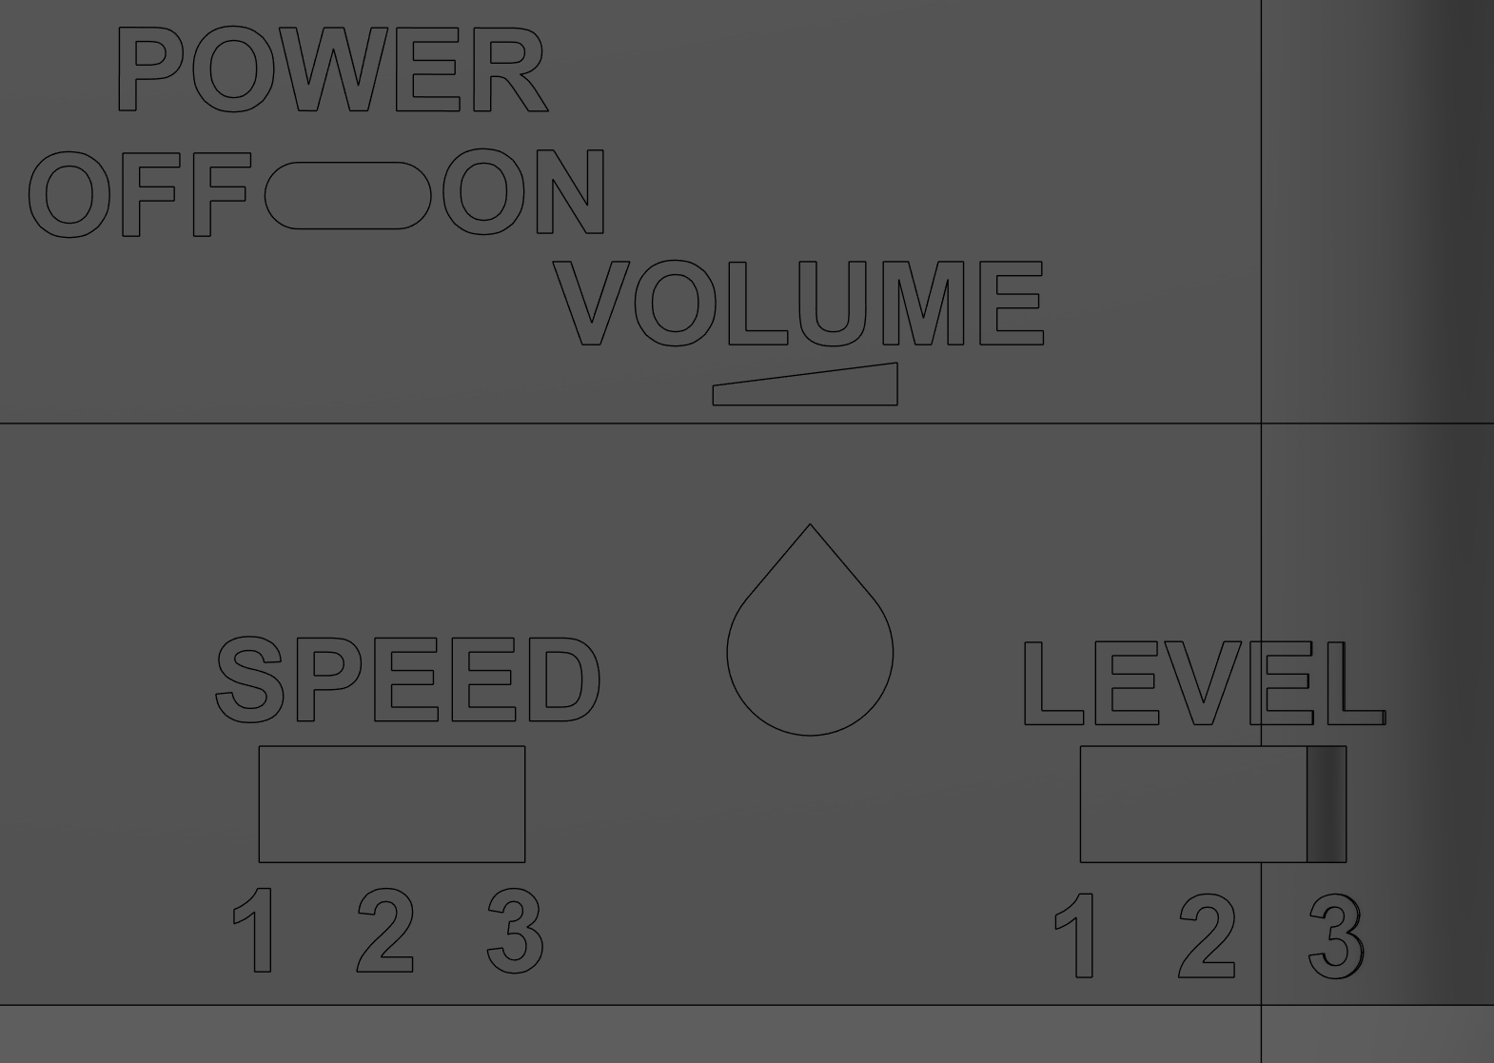

Figure 5: Screenshot of the labels on the back of the Chatterbox.

The snap fit between the two bottom quarters is dimensioned in the following figure:

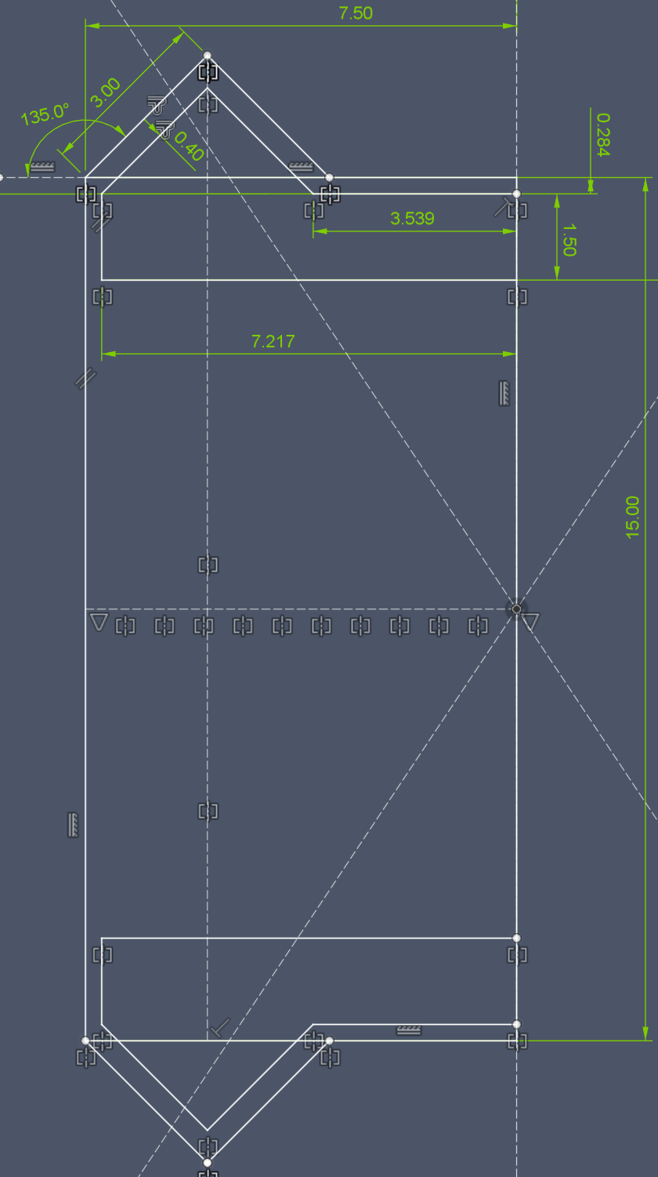

Figure 6: Dimensions of the snap fit connections between the bottom quarters of the Chatterbox.

The snap connection between the top quarters is dimensioned below:

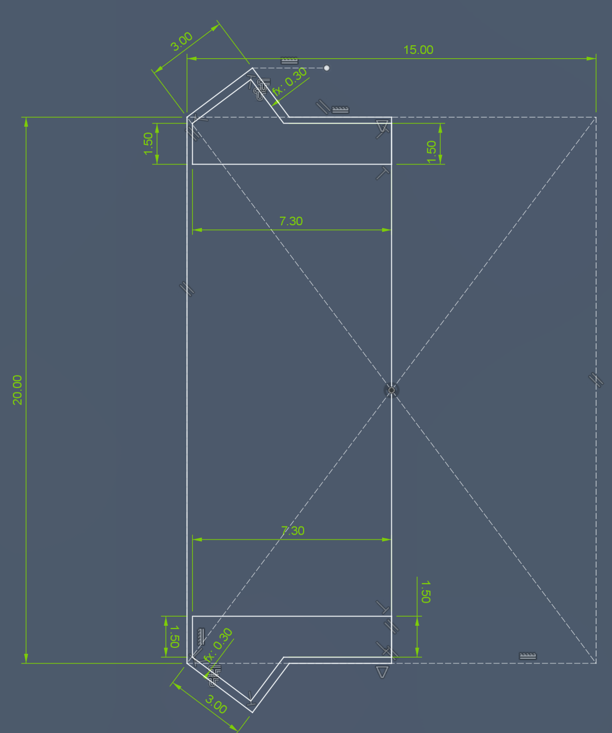

Figure 7: Dimensions of the snap fit between the top quarters of the Chatterbox.

Fillets and chamfers were added to break sharp edges on the snap fits.

#### Centre Supports

The centre supports were created to add more strength to the enclosure. These supports make the connection between quarters more snug, and add rigidity down the centre of the enclosure body. The added rigidity helps reduce twisting, bending, and flexing of the enclosure. The centre support for the bottom and top halves is the same, so there is only one STL file to print it.

The centre supports were again designed without the need for hardware to secure them, to reduce cost and increase ease of assembly/disassembly. The supports slide onto a dovetail joint to lock the two quarters together, and hold the support in place. Once the top and bottom halves are together, the two centre supports rest on each other, securing them vertically so they cannot move in the enclosure.



Figure 8: Screenshot of the bottom centre support holding the two bottom quarters together.

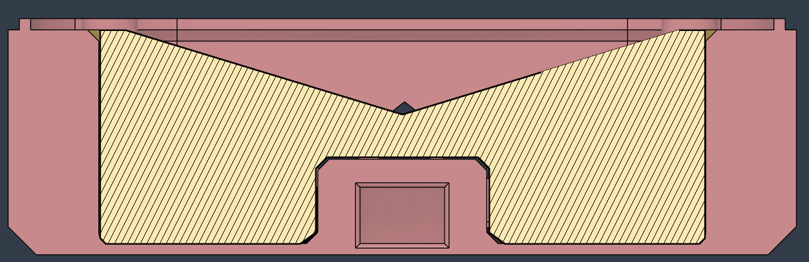

Figure 9: Cross-sectional view of the bottom centre support.

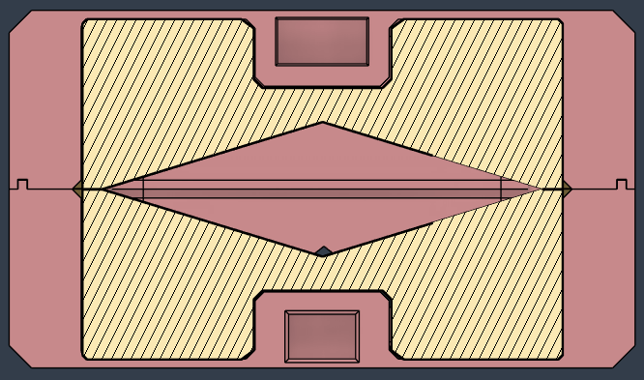

Figure 10: Cross-sectional view of both centre supports.

#### Label Holders

The label holders position the paper labels users can print out to identify the different messages on the Chatterbox. The label holders snap into the top of the enclosure with a similar snap fit used to connect the enclosure quarters. The label holders can hold a 76x72 mm label (wider than it is tall). The requestors of the device asked for the holders to fit labels of that size.

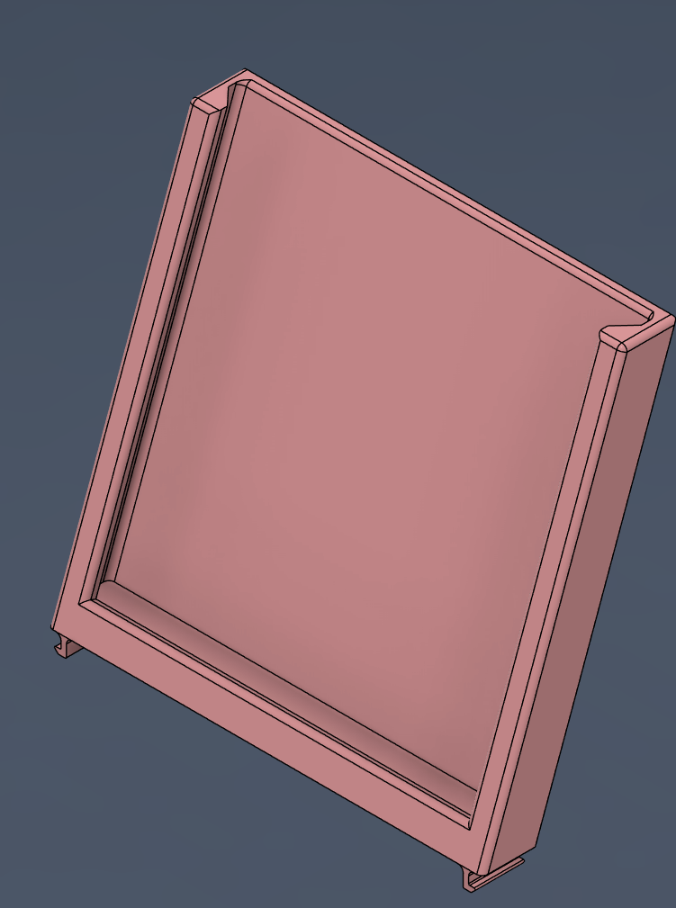

Figure 11: Label holder.

The snap fit tabs for connecting the label holders to the enclosure are 36.6 mm from the centre line of the holders to the inside, flat edge (without the hook). The dimensions for those tabs are below.

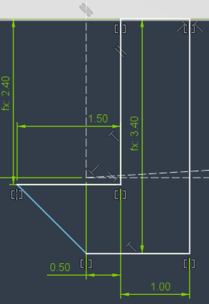

Figure 12: Dimensions of the snap fit tabs for the label holders.

#### Battery Cover

The battery cover holds the battery in place inside the Chatterbox, and makes it easy to access/replace the battery. The cover was adapted from a previous version of the Open Playback Recorder.

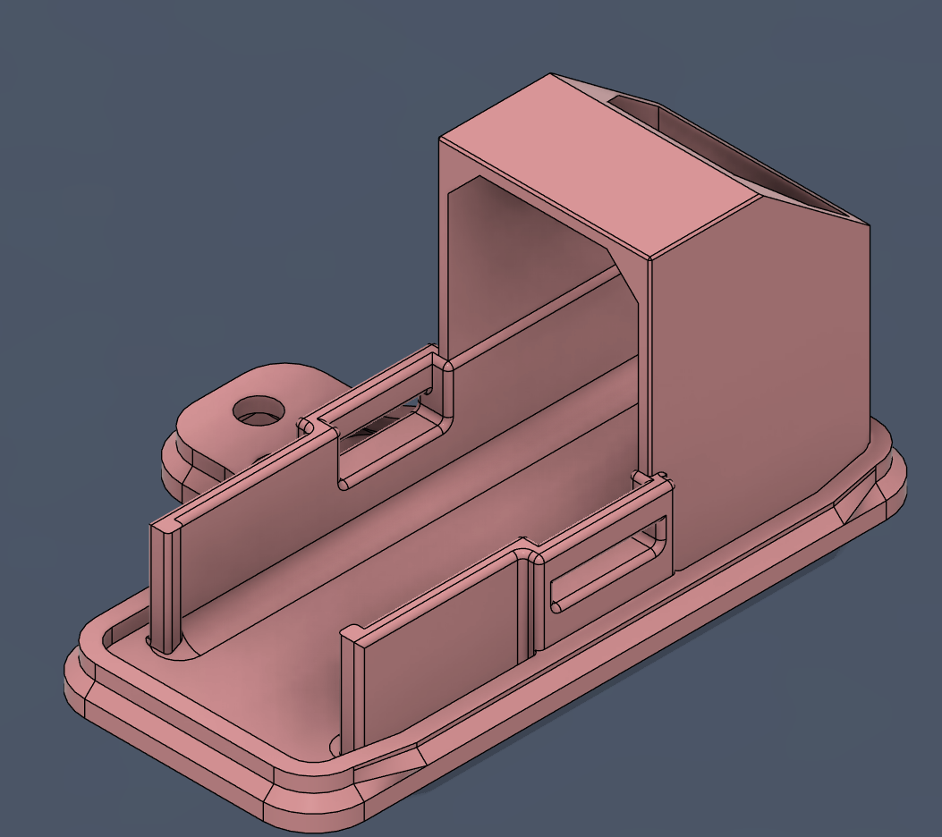

Figure 13: Screenshot of the battery cover.

The cutout at the back makes it easier to push a battery in and out of the cover. The battery cover is screwed into the bottom enclosure. The screw ensures a secure fit for the battery, and the need for a tool to remove the battery reduces the chances someone will accidentally access the battery or other internal components.

#### Volume knob

The volume knob slips over the exposed end of the potentiometer that controls the volume of the Chatterbox. The volume knob was reused from the Open Playback Recorder.

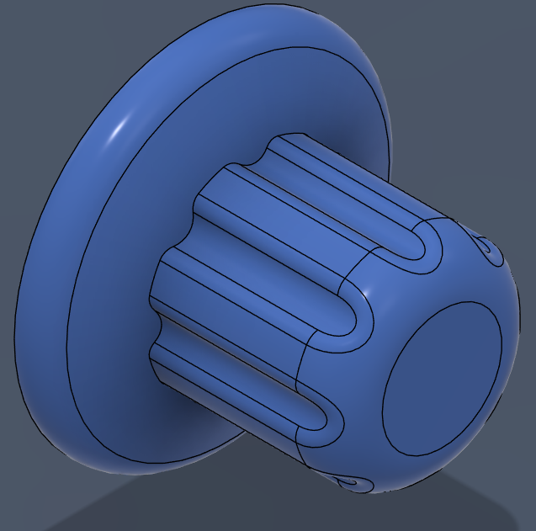

Figure 14: Screenshot of the 3D printed volume knob that covers the potentiometer.

### Direct Access Buttons

The direct access buttons are used to directly access messages on the Chatterbox, both for recording and playback. The buttons can be broken into the following subsystems:

* Button base (orange)
* Button insert (green)
* Button cap (turquoise)

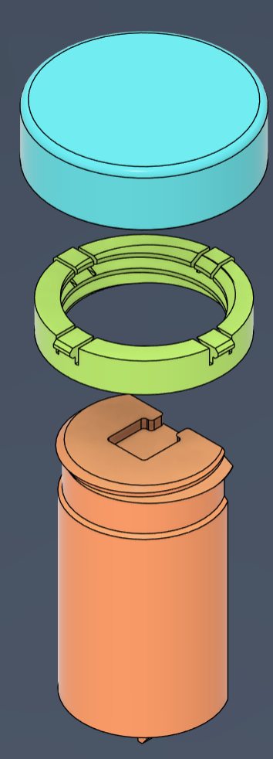

Figure 15: Screenshots of the direct access button assembly. Left: an exploded view of the base, insert, and cap. Right: Assembled view showing the base inserted into the enclosure bottom.

The direct access buttons were split into these subsystems to make 3D printing easier, and allow users to switch out the button caps without using tools. The idea behind switching the caps without tools is to allow users to customize switch caps for different messages, and easily change the cap based on the message. The base, insert, and cap are based on a design by [Switched Adapted Toys](https://www.switchedtoys.org/products/switch-kit-diy-3d-printed-switch-button-assembly-kit). The insert snaps into the cap, and then screws onto the base. The cap can slide up and down on the insert, letting it rest on a switch and activate the switch when pressed.

#### Button Base



Figure 16: Screenshot of the button base, showing the flat surface for 3D printing.

The button base is flat on one side to have a large surface for printing, and to give clearance to the wires that go to the switch. The switch sits in the cutout on the top of the base and is glued in place. The threads on the base are short, and the narrow section lets the insert spin freely. This flat section was added to prevent over-tightening the cap and insert. Over-tightening could damage the parts and/or constantly activate the switch.

The threads on the button base and insert are ISO Metric profile M45x4.5. That thread profile was suggested by Fusion 360 when modelling the threads, and was found to work effectively during test printing. The threads on the base were pressed in by 0.3 mm to add clearance for different printing tolerances.

The snap fit on the bottom of the button base is the same design as between the enclosure quarters. Dimensions are below. The sketch on the left is for the hole in the bottom enclosure quarters the button base snaps into, and the right side shows the dimensions of the snap tabs on the button base.

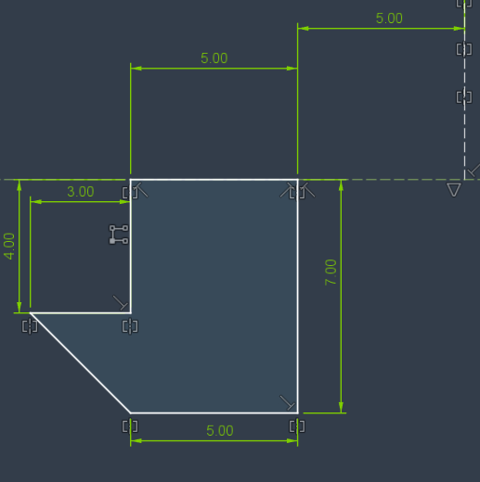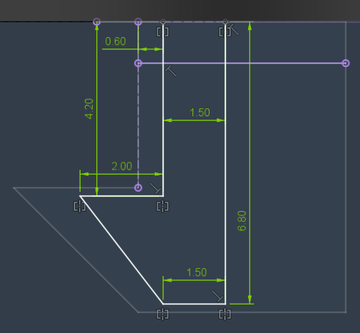

Figure 17: Dimensions of the slots and tabs for the button base snap fit. Left: Dimensions of the slot in the bottom enclosure. Right: Dimensions of the tabs on the button base, with the outline of the slots also visible.

#### Button Insert

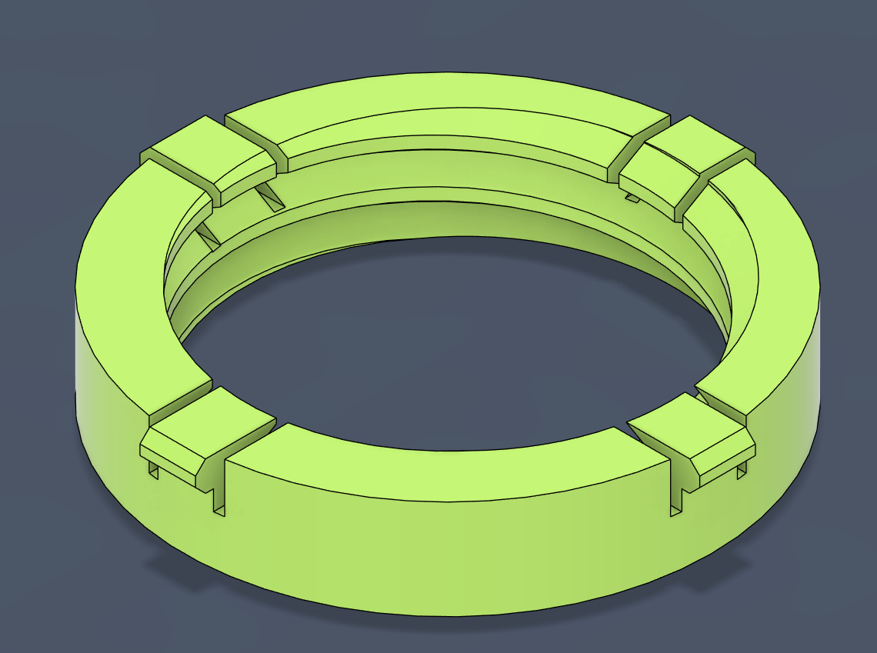

Figure 18: Screenshot of the button insert.

The button insert has four tabs which can flex to snap fit into the button cap. The threads on the inside of the insert allow users to screw the button insert and cap onto the button base. The dimensions for the insert tabs, cutouts, and inner and outer diameters are shown below.

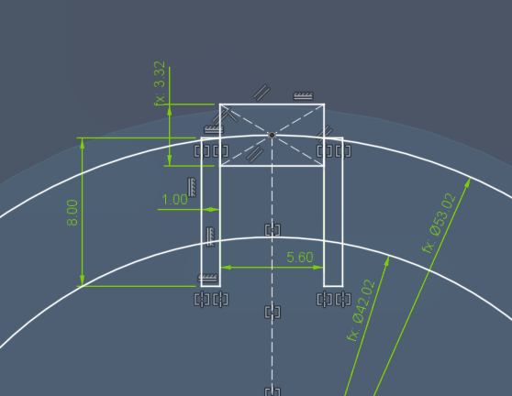

Figure 19: Dimensions of the button insert. The inner and outer diameters are shown, as well as the snap tabs and cutouts which allow the tabs to flex.

The insert is 10 mm tall, the tabs are 3 mm tall, and the cutouts to allow the tabs to flex are 5 mm deep.

#### Button Cap

The button cap has four slots which the flexible parts of the insert snap into. These slots also allow the cap to slide up and down on the insert to activate the switch. The cap was designed to print either on the flat top, or from the bottom up with bridging. The cap was designed to be printed with bridging to give more flexibility in custom 3D printed top options.

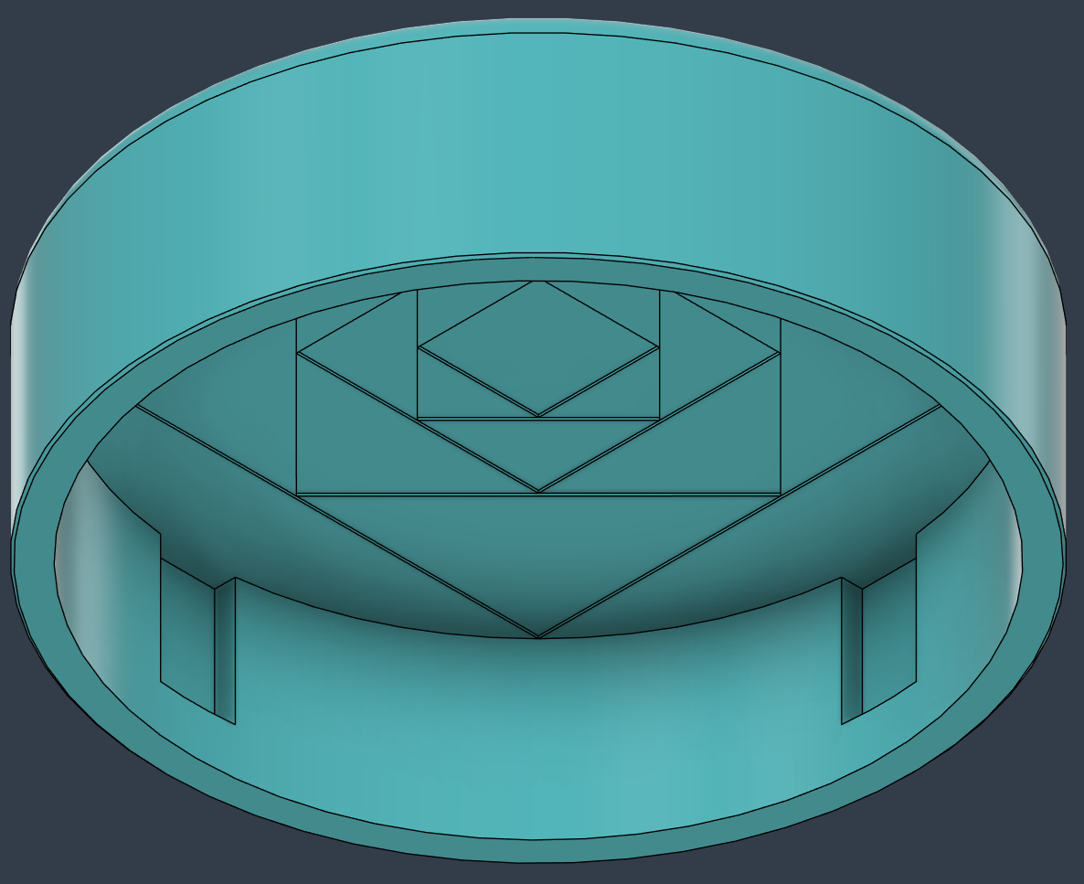

Figure 20: Screenshot of the underside of the button cap showing the slots for the snap fit tabs, and the design to reduce bridging distances.

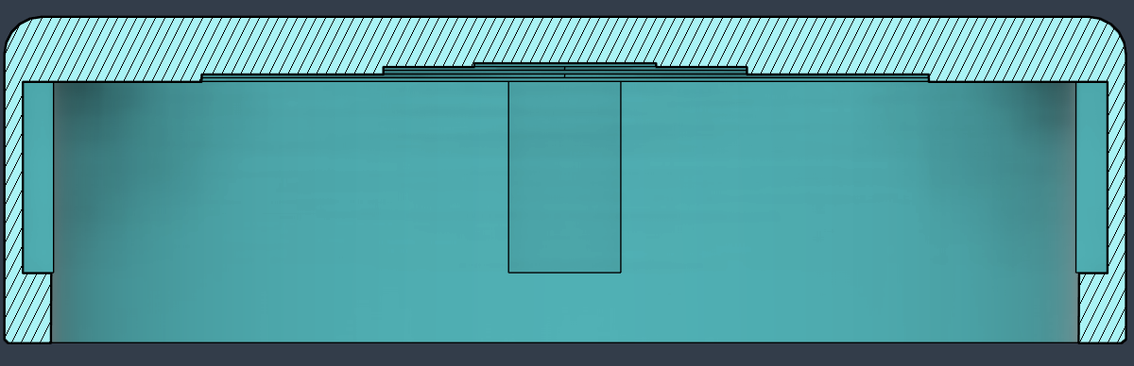

Figure 21: Cross-section of the button cap.

The dimensions of the cap are shown below.

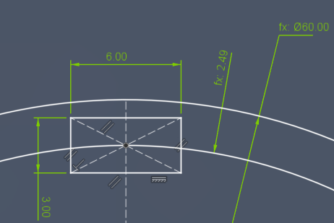

Figure 22: Dimensions of the button cap. The outer diameter, thickness, and the size of the slot for the snap fit tab are shown.

The button cap is 17.5 mm tall, and the slots for the tabs on the insert are 11.25 mm tall, from the bottom inside surface of the cap. The cap has the same thickness all around.

### Electrical Components

The electrical components can be split into two subsystems:

* Off-the-shelf electronics
* Custom PCBs
  + Main PCB
  + Secondary PCB
  + LED PCBs

#### Off-the-shelf components

The off-the-shelf components were mostly inherited from the Open Playback Recorder design, and kept because they worked effectively for recording and playing back messages. The Bill of Materials (BOM) has links to all the parts, prices, and quantities.

|  |  |  |
| --- | --- | --- |
| Part Name | Description/Use | Rationale for Choice |
| Seeeduino Nano | Microcontroller | * Had enough pins for required functions * Worked with TMRpcm library for recording and playing messages * Cheaper than Arduino Nano |
| Audio Amplifier (Pam8302) | Audio amplifier | * Gave flexibility in the speaker choice and placement compared to built-in amp/speaker combos |
| Mono speaker (4Ω 3W) | Speaker | * Small enough to easily fit, but strong enough to be heard easily in various environments |
| Audio potentiometer | Volume control | * Intuitive volume control |
| Micro SD Reader | Reading and writing to a micro SD card | * Gave flexibility in the messages that could be stored and positioning compared to not using an SD card |
| Micro SD card | Storing recorded messages | * Gave flexibility in the length and number of messages that could be recorded |
| Microphone (MAX9814) | Recording audio | * Small footprint microphone |
| Switches (B3F-5050) | Direct access switches | * Commonly used switch in many MMC devices * Reduces costs and complexity for MMC as we can order these in large quantities and use across many devices |
| Slide Switch (SPST) | Power and mode switches | * Affordable option used in multiple MMC devices |
| 3.5 mm Mono Jack | Assistive switch ports | * Affordable mono jack option used in multiple MMC devices |
| LEDs | Visual indicators for recording and playing back messages | * Affordable LEDs * Did not require LEDs to change colours, etc. |
| Resistors (2.2k Ω) | * Dropping voltage for LEDs * Resistor ladders for reading switch positions | * Drops voltage appropriately for LEDs * Drops voltage sufficiently to differentiate between switch positions * One value for all resistors to eliminate errors from incorrect resistor placement during assembly |
| Female headers (5, 8, and 15 pin) | Plugging in microcontroller, amp, microphone, and SD card reader to PCBs | * Used headers to make it easier to replace broken parts or salvage working boards from the Chatterbox |
| 9V battery | Powering the Chatterbox | * Delivered sufficient power for the Chatterbox * Smaller footprint than using combinations of other batteries (AA, AAA, etc.) |
| Capacitors (10µF) | Steadying voltage on power and audio lines | * Sufficient value to steady power and audio line voltages * Reduces noise in signals |
| 9V battery clip | Clip to attach 9V batteries to the PCB | * Easy to attach/detach the battery |
| 10 pin ribbon cable | Connecting main and secondary PCBs together | * Enough pins to send required signals between the two boards * Reduces complexity of assembly than attaching wires independently |
| 10 pin ribbon cable connector | Connect ribbon cable to PCBs | * Needed to connect ribbon cable to PCBs |
| Slide switch (SPDT) | Level and speed selection | * Simple and intuitive method for selecting levels and speeds |
| 24 AWG wire | * Connecting LED PCBs to Secondary PCB * Connecting direct access switches to Main PCB | * Common wire size used for MMC devices * Sufficient for current being passed along the wires |

#### Custom PCBs

To increase the reliability and durability of the PCBs, some of the default values in the Fusion 360 Design Rules were changed. Specifically, the width of the traces was changed, and this change was made across all PCBs.

|  |  |  |
| --- | --- | --- |
| Design Rule/Part | Description | Updated Value |
| Copper Width | Sets the default and minimum copper trace widths allowed on the PCB. | Minimum: 16 mil*  Preferred: 24 mil |
| Power Trace Width | Manually updated the width of any trace which was carrying power or high current (9V power, 5V power, 3.3 V power). | 50 mil |
| *Note: the default unit of PCB rules is mil (thousandths of an inch). 1 mil = 0.0254 mm | | |

Additionally, a ground pour was created on both sides of all boards (except the LED PCB, which was only done on one side since the board wiring is so simple). Ground planes were created across the entire top and bottom surfaces of the boards, making wiring simpler and grounds more reliable.

The ground pour was added to both sides of the boards, and then the Autorouter was used to run traces on the PCBs. The Autorouter routes were then manually inspected and modified to make sure there weren’t any isolated ground pours, and that copper traces were the correct width.

We used screws to mount all PCBs as we wanted these connections to be strong, reliable, and less likely to be affected by tolerance differences from different printers/materials.

As of writing, the Chatterbox has not been submitted or approved for Open Source Hardware certification from the Open Source Hardware Association (OSHWA). The OSHWA label has been added as a placeholder to the Main and Secondary PCBs, as we intend to get certification, and will be updated with the certification number.

##### Main PCB

The Main PCB did not change from the PCB Prototype. The schematic for the Main PCB is below.

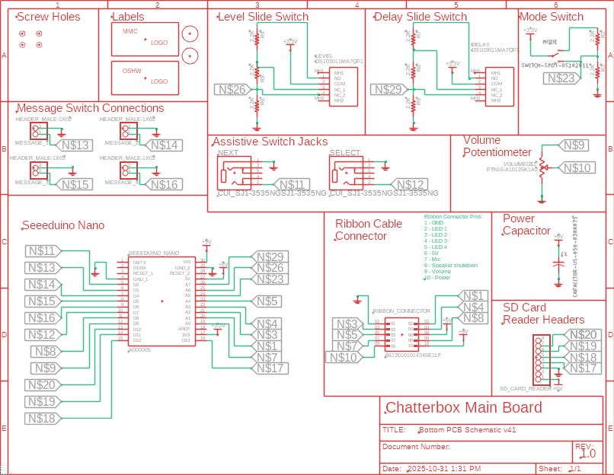

Figure 23: Screenshot of the electronic schematic for the Main PCB.

The power capacitor ensures a clean, steady voltage is supplied from the battery to the microcontroller.

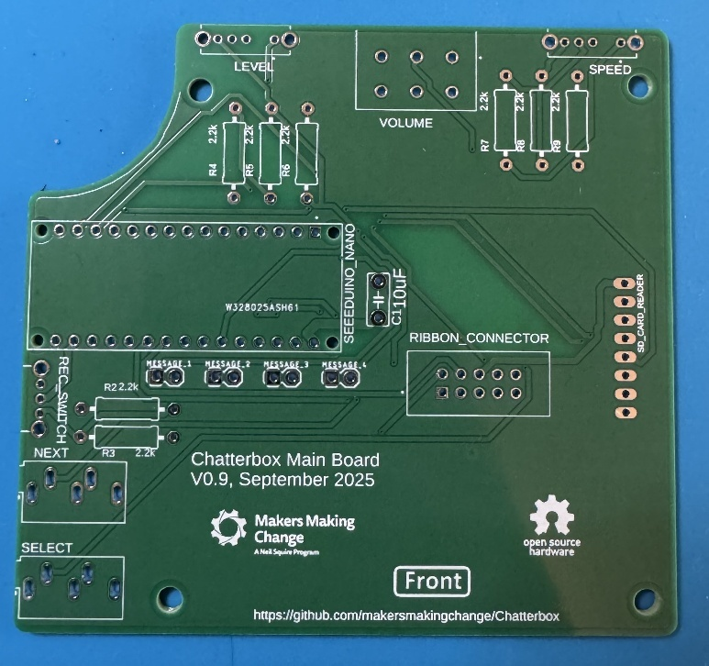

Figure 24: Picture of the front surface of the Main PCB.

##### Secondary PCB

We caught a mistake with some wiring on the Secondary PCB, and moved the LED PCBs to a separate board/schematic to decrease the cost of ordering them. The schematic and model of the Secondary PCB are below.

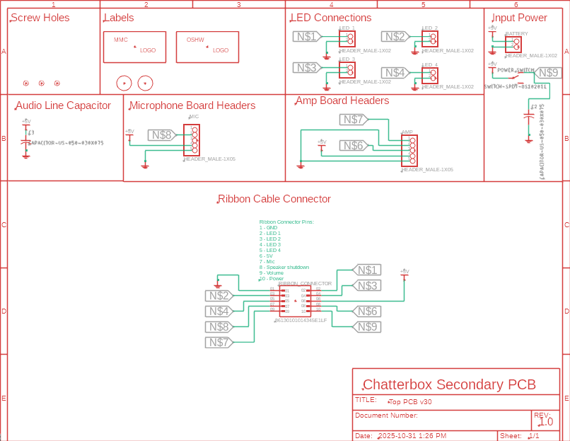

Figure 25: Screenshot of the electronic schematic of the Secondary PCB.

The capacitor on the power line ensures a clean, steady power supply from the battery to the ribbon cable connector. The capacitor on the Audio Line ensures a clean, steady supply of power to the Microphone and Amp boards, as changes in voltage could affect the audio quality.

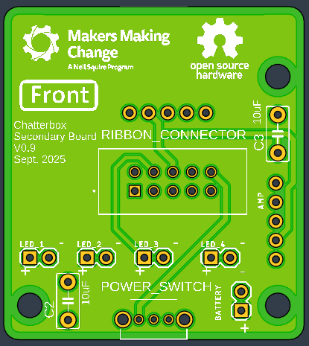

Figure 26: Screenshot of the front side of the Secondary PCB.

##### LED PCBs

The LED PCBs were moved to their own board, and makers are encouraged to order 20 of these boards since they need four per Chatterbox, and get five of each of the other boards anyway (enough for five Chatterboxes total). The schematic and model of the PCB are below.

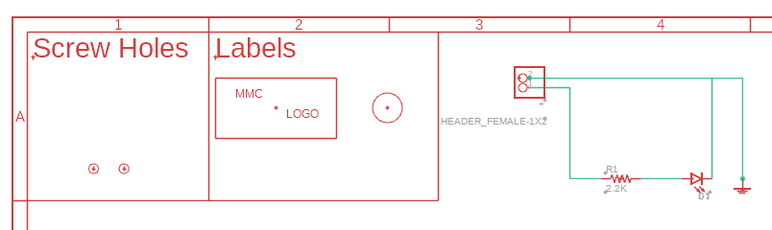

Figure 27: Screenshot of the electronic schematic for the LED PCBs.

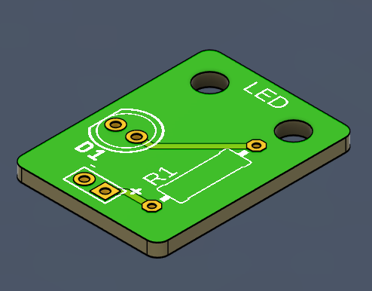

Figure 28: Screenshot of the front side of the LED PCB.

### Firmware

The code is the same as it was for the PCB Prototype. The firmware currently uses 70% of program storage space, and 72% of dynamic memory. Once the firmware reached a certain level of memory use (the exact value was not determined), the messages would not play back (they were treated as empty). Future updates to the code will need to consider these memory restrictions, unless a new microcontroller is used. The firmware can be found in the GitHub. The flowcharts showing the general code structure are below.

#### General Code Structure

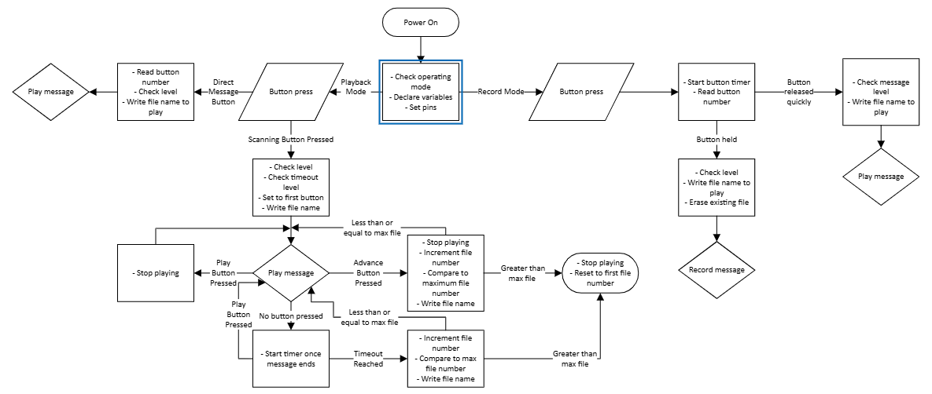

Figure 29: Flowchart showing the general code structure of the Chatterbox firmware.

#### Playback Code Structure

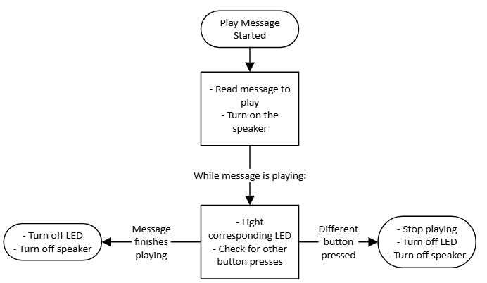

Figure 30: Flowchart showing how a message is played back.

#### Recording Code Structure

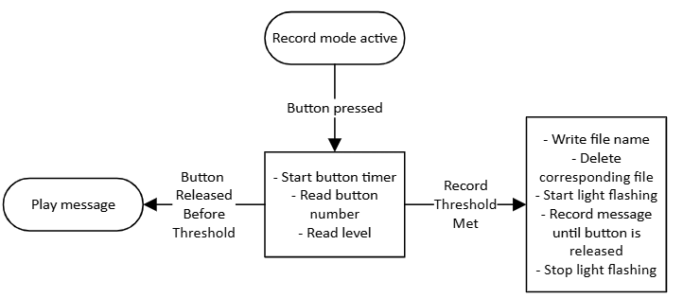

Figure 31: Flowchart showing how the Chatterbox responds to inputs when in the record mode.

#### Input Handling

##### Switch Debounce

Switch debouncing is handled in software. When a switch is pressed, there is a 50 ms delay in the code to “pause” it. The 50 ms delay was chosen based on testing with previous devices, and was found to be long enough to debounce effectively, without being noticeable to a user.

##### User-controlled settings

The settings that are controllable by a user without changing the firmware were all identified by the original requestors of the device. These include:

* Volume
* Playback delay
* Level
* Mode

The volume is controlled with a logarithmic potentiometer to match general analogue volume control on other devices (turning a knob adjusts the volume). The maximum volume is controlled in the firmware.

The playback delay has three durations that are set in the firmware. The user can select between these three options using a three-position slide switch. The choice of having three discrete options, and the default durations (2, 4, and 6 seconds) were made by the original requestors. The slide switch was chosen as it would only require on input pin on the microcontroller to change the delay, and provided feedback to the user on which delay was selected.

The level is also selected by using a slide switch. The level had to be adjustable by a secondary user without having to interact with the firmware. The slide switch was chosen for the same reason as for the playback delay.

The mode had to be controlled by the user to let them switch between recording and playing back messages. Having the distinct modes prevents users from accidentally deleting messages when trying to play them back. Modes are controlled with a two-position slide switch. The slide switch for changing modes was chosen for the same reason it was chosen for playback delay.

##### Firmware-controlled settings

Most values and settings in the firmware should not be changed. Most of the variables are set for the custom PCBs, or to control the firmware. Do not change the firmware unless you make corresponding changes to the PCBs, wiring of the device, and controls within the firmware.

There are a few settings that a user might want to adjust which are controlled in the firmware. These settings were kept to firmware as they weren’t settings a user would need to adjust often, if at all. The settings we identified were:

* Default playback delay values
* Blink interval
* Record interval
* Maximum volume

These variables are separated out in the code to make it easy to find them, and reduce the chance of accidentally changing the wrong variable. Currently they are between lines 112 and 118 of the firmware. They are sandwiched between two lines of commented percent signs (%%%%%%%) to make them easy to find when scrolling through the firmware.

The default playback delay values are an array with three values, and are in milliseconds (ms). The delay values can be set to any millisecond duration and should go from shortest to longest duration in the array.

The blink interval is the time for which LEDs are lit and off when blinking. The default of 500 ms was chosen arbitrarily as a medium blinking speed. The value can be changed to any millisecond value (shorter will speed up the blinking, longer will slow it down). Before changing, note that a longer blink interval might result in dead space at the beginning of a recorded message, as users might not realize the message has started recording as quickly as when the interval is smaller.

The record interval is how long a user needs to hold down a button in record mode before the firmware deletes the existing message and starts recording a new one. The one second value was chosen as a long enough time that someone likely won’t accidentally start recording, but short enough that it won’t be frustrating. The value can be changed to any duration, and is in ms.

The maximum volume is controlled as part of the TMRpcm library. It can be 0 to 7, and 5 was found to be a good value. Setting the maximum too high resulted in the speaker not playing, and too low will make it so users can’t hear the messages.

# Verification and Validation

This section defines the verification and validation (V&V) activities required to confirm that the device meets its design requirements, user and stakeholder needs, and applicable safety and performance expectations.

* Verification ensures the design was built correctly according to specifications.
* Validation ensures the right design was built, meeting user needs in real-world use.

## Verification

### Verification Objective

Confirm that all design requirements have been met through objective evidence such as inspection, analysis, or testing.

### Verification Methods

Common verification methods include:

* Inspection: Visual or measurement confirmation (e.g., enclosure dimensions, solder joints).
* Analysis: Analytical confirmation (e.g., thermal calculations, firmware memory usage).
* Test: Functional testing under controlled conditions (e.g., switch response time).
* Demonstration: Simple operational proof (e.g., assembly demonstration).

### Verification Matrix

Note: all verification was completed by Stephan Dobri (SD) as part of the design process of the Chatterbox.

|  |  |  |  |  |  |  |
| --- | --- | --- | --- | --- | --- | --- |
| Requirement ID | Requirement | Verification ID | Verification Method | Acceptance Criteria | Result / Status (Pass/fail, comment?) | Evidence Reference (linking to results/data that showed we passed the requirement) |
| F01 | Secondary users must be able to record their own messages. | V01 | Demonstration | The device allows users to record their own messages without needing to remove the SD card or using external firmware (ex: using a computer). | Pass | SD |
| F02 | Messages up to a minute in length must be possible to record. | V02 | Demonstration | Messages from <1 second to 60 seconds can be recorded. | Pass | SD recorded a message that was 78 seconds long and played it back successfully. |
| F03 | The device must record at least three separate messages. | V03 | Demonstration | The Chatterbox can record at least three messages. | Pass | SD |
| F04 | The device must work with single switch scanning. | V04 | Demonstration | The Chatterbox can be used with single switch scanning through an external assistive switch. | Pass | SD |
| F05a | Users must be able to add labels or pictures to help identify the messages | V05a | Demonstration | User can make and add their own labels to the messages. | Pass | SD |
| F05b | Labels must be a minimum size of 76x76 mm. | V05b | Inspection | Labels are 76x76 mm. | Marginal  Labels are 71x71 mm. Larger labels cannot be accommodated without making the device larger than the maximum length (F09). | Requestors stated slightly smaller labels than originally asked were large enough. |
| F06 | The delay between messages while switch scanning can be modified. | V06 | Demonstration | Secondary users can change the delay between messages while switch scanning without changing the firmware. | Pass | SD |
| F07 | The volume must be adjustable by secondary user. | V07 | Demonstration | Secondary users can adjust the volume while using the Chatterbox without changing the firmware. | Pass | SD |
| F08 | The device must be able to be cleaned with a damp cloth. | V08 | Demonstration | The Chatterbox can be cleaned with a damp cloth. | Pass | SD |
| F09 | The device must fit on a student’s lap tray (maximum length 330 mm). | V09 | Inspection | Maximum length less than 330 mm | Pass | SD |
| F10 | The device must be able to record and play at least two different levels of messages. | V10 | Demonstration | The Chatterbox can switch between and use at least two levels of messages without adjusting firmware. | Pass | SD |
| F10a | The device must have means to change level. | V10a | Demonstration | Secondary users can change the levels without changing the firmware. | Pass | SD |
| F10b | The device must have an indicator of current level. | V10b | Visual inspection | Secondary users can tell which level the Chatterbox is on without listening to messages. | Pass | SD |
| F11 | Integrated buttons on the device must be parallel to the surface the device is mounted or placed upon. | V11 | Inspection | The surface of the integrated buttons is parallel to the surface the Chatterbox is mounted/placed upon. | Pass | SD |
| F12 | The device enables switch-enabled auditory scanning. | V12 | Demonstration | The Chatterbox can be used with single switch scanning through an external assistive switch. | Pass | SD |
| F12a | The device plays pre-recorded messages when triggered by primary user. | V12a | Demonstration | The Chatterbox can be used with single switch scanning through an external assistive switch. | Pass | SD |
| F12b | The device must be able to record a message for each position. | V12b | Demonstration | The device allows users to record their own messages on each button independently, without needing to remove the SD card or using external firmware (ex: using a computer). | Pass | SD |
| F12c | The device must have a visual indicator for each position. | V12c | Visual Inspection | There are visual indicators to identify each message position. | Pass | SD |
| F12d | The device must have a means for indicating the current position. | V12d | Visual Inspection | Users can identify which message is being played, recorded, or selected from visual inspection. | Pass | SD |
| F12e | The device must play a selected message again when selected by the user. | V12e | Demonstration | The primary user can select a message to play back while switch scanning and the Chatterbox will play the full selected message. | Pass | SD |
| F13 | The device must have a way to indicate which position is being recorded. | V13 | Visual Inspection | Users can identify which message is being played, recorded, or selected from visual inspection. | Pass | SD |
| N/A | The device is more affordable than commercially available options. | V14 | Inspection | The device costs less than $300 CAD | Pass | Commercially Available Options section; SD |
| N/A | Determine the expected battery life of the device. | V15 | Inspection | The expected battery life is measured and reported. | Run times:  On in either mode: 19 hours  Playing a message at full volume: 3.2 hours  Recording a message: 18 hours  See appendix for details on measuring durrent draw. | SD |
| N/A | The device can survive being dropped off a desk/lap tray | V16 | Demonstration | Parts do not break when dropped off a desk. | Bottom of the enclosure split along layer lines after multiple drops. All other parts survived.  See appendix for details on drop tests. | SD, MMC staff |
| N/A | The device can be printed on different 3D printers and with different filament types. | V17 | Demonstration | The parts print successfully, and the tolerances work on multiple different printers and with different filaments. | Pass | SD |

### Verification Summary

All requirements were met except F05. Recommend that original requirement is amended for smaller size (71 mm instead of 76 mm). This reduction should be validated with the stakeholders to ensure that this smaller size still meets their needs (i.e., not concerned about compatibility with existing larger templates).

## Validation

### Validation Objective

**C**onfirm that the final design meets user and stakeholder needs in its intended context of use.

### Validation Questions

The following list of questions was used for brainstorming what to ask the users on the Microsoft Form.

* LEDs
  + Bright enough?
  + Easy to see for primary and secondary user?
  + Colour preference?
  + Do they need to stick out of the top?
* Label holders
  + Ease of creating new labels
  + Ease of swapping labels
  + Visibility of labels
  + Is the 76 mm size critical? Are there existing templates / labels that require this size?
* User Guide
  + Clarity of information
  + Length appropriate?
  + Anything missing?
* Recording
  + Easy to record new messages?
* Playback
  + Playback clear/any audio issues?
  + Sound board option?
* Switch Scanning
  + Works as intended?
  + Any issues with any assistive switches?
  + Are default delay times sufficient?
  + Switch scanning delay from start or end of message?
  + Using single switch scanning vs dual switch scanning
    - Need separate operating modes? (delay triggers playback instead of advancing message)
* Slide switches
  + Easy to access and move switches?
  + Easy to control position/know what speed or level you’re in?
* Switch caps
  + Easy to customize?
  + Easy to switch out caps?
* Size and shape
  + Is height of device acceptable?
  + Weight appropriate?
* Any other comments/feedback?

### Validation Matrix

|  |  |  |  |  |  |
| --- | --- | --- | --- | --- | --- |
| Validation ID | Validation Objective | Participant(s) | Procedure | Acceptance Criteria | Result / Comment |
| End-user Validation | | | | | |
| Val01 | Ensure audio playback is clear and audible. | Surrey School AAC Team, Kingston OTs, Set BC team | Provide prototype for participants to test. | Testers verify the audio is clear and audible. |  |
| Val02 | Ensure secondary users can record messages. | Surrey School AAC Team, Kingston OTs, Set BC team | Provide prototype for participants to test. | Secondary users recorded their own messages without issue. |  |
| Val03 | Ensure single switch scanning works as intended. | Surrey School AAC Team, Kingston OTs, Set BC team | Provide prototype for participants to test. | Users navigated messages through single switch scanning. |  |
| Val04 | Ensure dual switch scanning works as intended. | Surrey School AAC Team, Kingston OTs, Set BC team | Provide prototype for participants to test. | Users navigated messages with dual switch scanning. |  |
| Val05 | Determine appropriate default delay time lengths between messages. | Surrey School AAC Team, Kingston OTs, Set BC team | Provide prototype for participants to test. | Testing participants provide appropriate default delay times. |  |
| Val06 | Determine if changing switch caps is difficult for secondary users. | Surrey School AAC Team, Kingston OTs, Set BC team | Provide prototype for participants to test. | Secondary users can change the switch caps without separating the top and bottom halves of the enclosure. |  |
| Val07 | Ensure the device is an acceptable size. | Surrey School AAC Team, Kingston OTs, Set BC team | Provide prototype for participants to test. | Testers verify the Chatterbox is an acceptable size. |  |
| Val08 | Ensure the device is an acceptable weight. | Surrey School AAC Team, Kingston OTs, Set BC team | Provide prototype for participants to test. | Testers verify the Chatterbox is an acceptable weight. |  |
| Val09 | Ensure switching between modes is reliable. | Surrey School AAC Team, Kingston OTs, Set BC team | Provide prototype for participants to test. | Secondary users can reliably change between recording and playback modes. |  |
| Val10 | Ensure switching between levels is reliable. | Surrey School AAC Team, Kingston OTs, Set BC team | Provide prototype for participants to test. | Secondary users can reliably select the level they would like using the slide switch. |  |
| Val11 | Ensure visual feedback for the level is clear. | Surrey School AAC Team, Kingston OTs, Set BC team | Provide prototype for participants to test. | Secondary users can tell which level the Chatterbox is on by looking at the slide switch. |  |
| Val12 | Ensure switching between delays is reliable. | Surrey School AAC Team, Kingston OTs, Set BC team | Provide prototype for participants to test. | Secondary users can reliably select the delay they would like using the slide switch. |  |
| Val13 | Ensure visual feedback for the delay is clear. | Surrey School AAC Team, Kingston OTs, Set BC team | Provide prototype for participants to test. | Secondary users can tell which delay the Chatterbox is on by looking at the slide switch. |  |
| Val14 | Ensure visual feedback for which message is playing, recording, or being selected is clear. | Surrey School AAC Team, Kingston OTs, Set BC team | Provide prototype for participants to test. | Users can see and differentiate between the indicator LEDs. |  |
| Val15 | Ensure the label holders are sufficiently large. | Surrey School AAC Team, Kingston OTs, Set BC team | Provide prototype for participants to test. | Users can see the labels. |  |
| Val16 | Ensure secondary users can create labels for messages. | Surrey School AAC Team, Kingston OTs, Set BC team | Provide prototype for participants to test. | Secondary users can create their own labels printed on paper. |  |
| Val17 | Ensure secondary users can change the labels for messages. | Surrey School AAC Team, Kingston OTs, Set BC team | Provide prototype for participants to test. | Secondary users do not report issues adding or removing paper labels. |  |
| Val18 | Ensure device function is simple enough that users are learning to switch scan, not learning to use the device. | Surrey School AAC Team, Kingston OTs, Set BC team | Provide prototype for participants to test. | Users are able to learn switch scanning, rather than the specifics of how to use the Chatterbox. |  |
| Val19 | Ensure the User Guide is not missing information. | Surrey School AAC Team, Kingston OTs, Set BC team | Provide participants with the User Guide to read through and reference when testing the Chatterbox. | Secondary users provide feedback on what information should be added to the User Guide. |  |
| Val20 | Ensure the User Guide is written clearly. | Surrey School AAC Team, Kingston OTs, Set BC team | Provide participants with the User Guide to read through and reference when testing the Chatterbox. | Secondary users provide feedback on how to make the User Guide more clear. |  |
| Volunteer Maker Validation | | | | | |
| Val21 | Ensure Maker Guide is not missing information. | Volunteer maker in Burnaby, BC | Have volunteer maker go through Maker Guide. | Volunteer provides feedback on missing information that can be added. | Volunteer suggested minor revisions/additions. |
| Val22 | Ensure Maker Guide is written clearly. | Volunteer maker in Burnaby, BC | Have volunteer maker go through Maker Guide. | Volunteer provides feedback to improve clarity that can be completed. | Volunteer suggested minor revisions/additions. |
| Val23 | Ensure maker can follow Assembly Guide to create a functioning device. | Volunteer maker in Burnaby, BC | Have volunteer maker make a prototype. | Volunteer successfully builds a working Chatterbox. | Volunteer successfully built working Chatterbox. |

#### Validation Methods

##### User Testing

User testing was completed by multiple user groups, and all groups were given access to a [Microsoft Form to collect feedback](https://forms.office.com/Pages/DesignPageV2.aspx?origin=NeoPortalPage&subpage=design&id=DsX1YrmQmUWIO5C199RGrAIqOZVKyvpGuJ3MQjLdtA9UOUtYR0M2MU9MRVhIVUYxRE4xN0cxNlY1SC4u). The questions in the form were designed to help guide user testing, to collect specific feedback we identified as required, and to allow open feedback. The users were also provided the User and Quickstart Guides to learn how to use the Chatterbox.

##### Maker Testing

A volunteer maker in Burnaby, BC, was asked to assemble a Chatterbox, following the Assembly Instructions in the Maker Guide. The goal was to have someone unfamiliar with the device follow the instructions to make sure they are clear and nothing is missing.

Ideally, we will get another maker to independently go through the whole process of making a Chatterbox, including ordering the PCBs.

Note: Stephan Dobri (SD) completed the verification testing

Table 2. Traceability Matrix

|  |  |  |  |  |
| --- | --- | --- | --- | --- |
| User Need | Requirement ID | Verification ID | Validation ID | Evidence Reference |
| A switch scanning communication device that uses auditory feedback for switch scanning. | F12 | V12 | Val01-Val18 | SD / User testing |
| Device is simple to help teach users how to switch scan rather than learning how to use the device. | N/A | N/A | Val18 | User testing |
| Device should have integrated switches to directly play and record messages. | F01, F02, F03, F10, F12b | V01, V02, V03, V10, V12b | Val02, Val09 | SD / User testing |
| The device can do single or dual switch scanning. | F04, F12a, F12e | V04, V12a, V12e | Val03, Val04 | SD / User testing |
| The volume of the device can be controlled. | F07 | V07 | Val01 | SD / User testing |
| The delay between scanning messages can be controlled. | F06 | V06 | Val12, Val13 | SD / User testing |
| The device can hold images on paper near each switch to represent the message. | F05 | V05 | Val15-Val17 | SD / User testing |
| The device can record and play at least three messages. | F01, F03 | V01, V03 | Val02, Val09, Val17 | SD / User testing |
| The device is more affordable than current commercially available options. | N/A | V14 | N/A | Commercially Available Options section |
| The device is small enough to fit on a user’s lap tray. | F09 | V09 | Val07, Val08 | SD / User testing |
| The device has different message levels to record, and playback sets of messages. | F10 | V10 | Val10, Val11 | SD / User testing |
| The device shows which level it is on. | F10b | V10b | Val11 | SD / User testing |
| The device shows which message is being played/recorded. | F12c, F12d, F13 | V12c, V12d, V13 | Val14 | SD / User testing |

## Verification and Validation Summary

The Chatterbox passed all verification tests.

The smaller than originally specified size of the labels (71 mm instead of 76 mm) was validated by the original requestors, as suggested in the Verification Summary.

# Opportunities for Improvement

### Physical Component / Enclosure

* Perform drop tests with PETG assembly
* Improve strength and durability of the enclosure
* Complete drop tests with aged prints (PLA gets more brittle with age)
* Test snap fits on aged prints
* Make 3D printed toggles for slide switches

### Electrical Components

* Explore more power options
  + Rechargeable batteries, etc.

### Code Structure / Function

* Change volume between message preview and message playback while switch scanning
* Change some repeated code snippets into functions to improve readability and ease of updating
* Update code to only play preview of messages instead of the full message while switch scanning

# Appendix

## Verification Test Descriptions

Most of the verification testing on the Chatterbox was simple confirmation of functionality of the firmware and hardware. Since most of the electronics were reused from the Open Playback Recorder, testing the compatibility of code libraries and the electronics were not needed.

### Firmware testing

Table 3: Summary of firmware tests and descriptions

|  |  |
| --- | --- |
| Test | Description |
| Battery power | Check the device powers on from the battery |
| Mode switch | * Check the Mode switch changes modes * Check all LEDs blink while in Record Mode |
| Record Messages | * Record a message on each button on one level * Check that only the one LED blinks while recording on a switch * Check that the messages play back in Record Mode * Check that playback is audible/clear * Check if messages up to 60 seconds could be recorded and played back |
| Level switch | * Check that moving the Level switch changes the recording/playback level * Record new messages for each button at each level * Check that message play back in Record Mode |
| Message Playback | * Check that messages play back in Playback mode * Check that only the LED for the message being played lights up |
| Switch Scanning | * Check that pressing the Select switch once starts switch scanning * Check that the LED for a message stays lit during the delay before playing the next message * Check that only the playing message LED stays lit * Check that switch scanning stops if the last message times out * Check that pressing the Select switch again while switch scanning replays the current message * Check that switch scanning works with multiple types of assistive switches |
| Next switch | * Check that pressing the Next switch when not switch scanning does nothing * Check that pressing the Next switch while switch scanning moves to the next message |
| Speed switch | * Check that moving the Speed switch changes the length of the delay between messages being automatically played while switch scanning * Check all three speeds |
| Volume | * Check that the volume knob changes the volume of the messages |

The tests for firmware were all passed for the PCB prototype, which is the current version of the Chatterbox.

### Current Draw/Battery Life Measurement and Calculation

Current draw was measured by adding a 1 Ohm resistor in series with the Chatterbox electronics, and measuring the voltage across that resistor with an Arduino Uno. The circuit diagram is shown below, where the “test load” represents the Chatterbox.

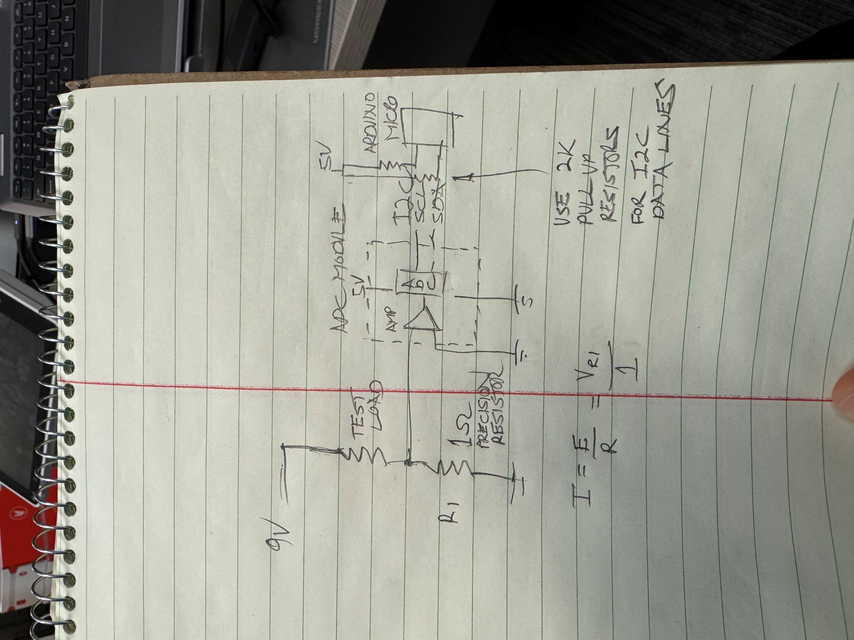

Figure 32: Circuit diagram for testing current draw of the Chatterbox.

The testing setup included a 1 Ohm resistor, an Adafruit ADS1115 ADC board, and an Arduino Uno. The ADC converted analog signals (the voltage across the resistor) to a digital signal which could be read and recorded by the Arduino Uno. The low resistance of the 1 Ohm resistor theoretically adds a negligible load compared to the Chatterbox, so measuring the voltage across and calculating the current draw should be representative of the current the Chatterbox would draw from the battery without the resistor. Knowing the current draw of the Chatterbox while in operation, and the capacity of the battery allows us to calculate how long the Chatterbox can run before needing to replace the battery.

The wiring and code for recording this data were pulled directly from the [Adafruit guide for the ADS1115](https://learn.adafruit.com/adafruit-4-channel-adc-breakouts). The differential voltage was measured across the resistor, rather than taking a single voltage reading at the resistor and comparing that to ground of the Arduino. The code is pasted below:

#include <Wire.h>

#include <Adafruit_ADS1X15.h>

Adafruit_ADS1115 ads1115; // Construct an ads1115

void setup(void)

{

  Serial.begin(9600);

  ads1115.begin();  // Initialize ads1115 at the default address 0x48

}

void loop() {

  // put your main code here, to run repeatedly:

  int16_t results;

  results = ads1115.readADC_Differential_0_1(); // Read the difference between the ADC pins (ground and voltage at the resistor)

  Serial.println(results); // Print results to Serial Monitor

  delay(100); // Add short delay to reduce sampling rate/size of data file.

}

The current draw was recorded for four different working conditions: the Chatterbox being on but idle in both Playback and Record modes, playing a message at maximum volume, and recording a message. These four conditions were chosen as they represent the four main states the Chatterbox would be in while operating. Playing messages was only measured at maximum volume as that would require the highest current draw, therefore the shortest battery life.

For each working condition, the output of the serial monitor was copied into an Excel spreadsheet, and the average current draw was calculated. The current was calculated using the following equations:

$$V=Serial Reading*188$$

Where the *Serial Reading* is the output to the serial monitor from the Arduino, and the factor 188 is the voltage per bit, in micro volts (as per the Adafruit guide).

$$I=\frac{V}{R}=\frac{V}{1Ω}$$

Where *I* is the current draw and *V* is the voltage measured across the resistor.

The average current draw was then used to calculate the expected run time in that working condition. The capacity of the battery from the bill of materials is 580 mAh, according to the [Newark product page](https://canada.newark.com/duracell/mn1604bkd/battery-alkaline-manganese-dioxide/dp/65W8052), which links to the [datasheet for the battery](https://www.farnell.com/datasheets/3625657.pdf). Duracell does not provide the capacity of these batteries, as far as we have been able to find.

The four fun times are summarized in the table below, and the raw data are in the following tables.

Table 4: Expected run times based on current draw

|  |  |
| --- | --- |
| Running Condition | Expected run time (hours) |
| Idle in Playback Mode | 19.4 |
| Playing a message a full volume | 3.2 |
| Idle in Record Mode | 18.9 |
| Recording a message | 17.9 |

Table 5: Voltage and current draw while idle in Playback Mode

|  |  |  |  |
| --- | --- | --- | --- |
| Differential Reading (bits) | Voltage (uV) | Current Draw (mA) | Expected run time of battery (h) |
| 156 | 29328 | 29.328 | 19.8 |
| 157 | 29516 | 29.516 | 19.7 |
| 157 | 29516 | 29.516 | 19.7 |
| 157 | 29516 | 29.516 | 19.7 |
| 157 | 29516 | 29.516 | 19.7 |
| 157 | 29516 | 29.516 | 19.7 |
| 157 | 29516 | 29.516 | 19.7 |
| 157 | 29516 | 29.516 | 19.7 |
| 157 | 29516 | 29.516 | 19.7 |
| 156 | 29328 | 29.328 | 19.8 |
| 157 | 29516 | 29.516 | 19.7 |
| 157 | 29516 | 29.516 | 19.7 |
| 157 | 29516 | 29.516 | 19.7 |
| 157 | 29516 | 29.516 | 19.7 |
| 157 | 29516 | 29.516 | 19.7 |
| 157 | 29516 | 29.516 | 19.7 |
| 157 | 29516 | 29.516 | 19.7 |
| 157 | 29516 | 29.516 | 19.7 |
| 157 | 29516 | 29.516 | 19.7 |
| 157 | 29516 | 29.516 | 19.7 |
| 156 | 29328 | 29.328 | 19.8 |
| 157 | 29516 | 29.516 | 19.7 |
| 157 | 29516 | 29.516 | 19.7 |
| 157 | 29516 | 29.516 | 19.7 |
| 157 | 29516 | 29.516 | 19.7 |
| 157 | 29516 | 29.516 | 19.7 |
| 157 | 29516 | 29.516 | 19.7 |
| 157 | 29516 | 29.516 | 19.7 |
| 157 | 29516 | 29.516 | 19.7 |
| 157 | 29516 | 29.516 | 19.7 |
| 157 | 29516 | 29.516 | 19.7 |
| 157 | 29516 | 29.516 | 19.7 |
| 156 | 29328 | 29.328 | 19.8 |
| 157 | 29516 | 29.516 | 19.7 |
| 156 | 29328 | 29.328 | 19.8 |
| 156 | 29328 | 29.328 | 19.8 |
| 157 | 29516 | 29.516 | 19.7 |
| 157 | 29516 | 29.516 | 19.7 |
| 156 | 29328 | 29.328 | 19.8 |
| 157 | 29516 | 29.516 | 19.7 |
| 157 | 29516 | 29.516 | 19.7 |
| 157 | 29516 | 29.516 | 19.7 |
| 156 | 29328 | 29.328 | 19.8 |
| 157 | 29516 | 29.516 | 19.7 |
| 157 | 29516 | 29.516 | 19.7 |
| 156 | 29328 | 29.328 | 19.8 |
| 157 | 29516 | 29.516 | 19.7 |
| 156 | 29328 | 29.328 | 19.8 |
| 156 | 29328 | 29.328 | 19.8 |
| 157 | 29516 | 29.516 | 19.7 |
| 156 | 29328 | 29.328 | 19.8 |
| 156 | 29328 | 29.328 | 19.8 |
| 157 | 29516 | 29.516 | 19.7 |
| 157 | 29516 | 29.516 | 19.7 |
| 157 | 29516 | 29.516 | 19.7 |
| 156 | 29328 | 29.328 | 19.8 |
| 156 | 29328 | 29.328 | 19.8 |
| 156 | 29328 | 29.328 | 19.8 |
| 157 | 29516 | 29.516 | 19.7 |
| 157 | 29516 | 29.516 | 19.7 |
| 157 | 29516 | 29.516 | 19.7 |
| 157 | 29516 | 29.516 | 19.7 |
| 156 | 29328 | 29.328 | 19.8 |
| 157 | 29516 | 29.516 | 19.7 |
| 157 | 29516 | 29.516 | 19.7 |
| 157 | 29516 | 29.516 | 19.7 |
| 157 | 29516 | 29.516 | 19.7 |
| 157 | 29516 | 29.516 | 19.7 |
| 156 | 29328 | 29.328 | 19.8 |
| 157 | 29516 | 29.516 | 19.7 |
| 157 | 29516 | 29.516 | 19.7 |
| 156 | 29328 | 29.328 | 19.8 |
| 156 | 29328 | 29.328 | 19.8 |
| 156 | 29328 | 29.328 | 19.8 |
| 157 | 29516 | 29.516 | 19.7 |
| 157 | 29516 | 29.516 | 19.7 |
| 156 | 29328 | 29.328 | 19.8 |
| 157 | 29516 | 29.516 | 19.7 |
| 157 | 29516 | 29.516 | 19.7 |
| 156 | 29328 | 29.328 | 19.8 |
| 157 | 29516 | 29.516 | 19.7 |
| 157 | 29516 | 29.516 | 19.7 |
| 159 | 29892 | 29.892 | 19.4 |
| 159 | 29892 | 29.892 | 19.4 |
| 163 | 30644 | 30.644 | 18.9 |
| 170 | 31960 | 31.96 | 18.1 |
| 168 | 31584 | 31.584 | 18.4 |
| 171 | 32148 | 32.148 | 18.0 |
| 189 | 35532 | 35.532 | 16.3 |
| 187 | 35156 | 35.156 | 16.5 |
| 181 | 34028 | 34.028 | 17.0 |
| 185 | 34780 | 34.78 | 16.7 |
| 184 | 34592 | 34.592 | 16.8 |
| 182 | 34216 | 34.216 | 17.0 |
| 181 | 34028 | 34.028 | 17.0 |
| 180 | 33840 | 33.84 | 17.1 |

Table 6: Voltage and current while playing a message back at full volume

|  |  |  |  |
| --- | --- | --- | --- |
| Differential Reading (bits) | Voltage (uV) | Current Draw (mA) | Expected run time of battery (h) |
| 945 | 177660 | 177.66 | 3.26 |
| 947 | 178036 | 178.036 | 3.26 |
| 942 | 177096 | 177.096 | 3.28 |
| 932 | 175216 | 175.216 | 3.31 |
| 954 | 179352 | 179.352 | 3.23 |
| 928 | 174464 | 174.464 | 3.32 |
| 977 | 183676 | 183.676 | 3.16 |
| 942 | 177096 | 177.096 | 3.28 |
| 1020 | 191760 | 191.76 | 3.02 |
| 932 | 175216 | 175.216 | 3.31 |
| 933 | 175404 | 175.404 | 3.31 |
| 969 | 182172 | 182.172 | 3.18 |
| 1009 | 189692 | 189.692 | 3.06 |
| 1035 | 194580 | 194.58 | 2.98 |
| 999 | 187812 | 187.812 | 3.09 |
| 965 | 181420 | 181.42 | 3.20 |
| 939 | 176532 | 176.532 | 3.29 |
| 1013 | 190444 | 190.444 | 3.05 |
| 993 | 186684 | 186.684 | 3.11 |
| 932 | 175216 | 175.216 | 3.31 |
| 1019 | 191572 | 191.572 | 3.03 |
| 949 | 178412 | 178.412 | 3.25 |
| 932 | 175216 | 175.216 | 3.31 |
| 952 | 178976 | 178.976 | 3.24 |
| 937 | 176156 | 176.156 | 3.29 |
| 978 | 183864 | 183.864 | 3.15 |
| 1010 | 189880 | 189.88 | 3.05 |
| 976 | 183488 | 183.488 | 3.16 |
| 932 | 175216 | 175.216 | 3.31 |
| 951 | 178788 | 178.788 | 3.24 |
| 938 | 176344 | 176.344 | 3.29 |
| 929 | 174652 | 174.652 | 3.32 |
| 960 | 180480 | 180.48 | 3.21 |
| 1044 | 196272 | 196.272 | 2.96 |
| 1032 | 194016 | 194.016 | 2.99 |
| 976 | 183488 | 183.488 | 3.16 |
| 941 | 176908 | 176.908 | 3.28 |
| 932 | 175216 | 175.216 | 3.31 |
| 1025 | 192700 | 192.7 | 3.01 |
| 1107 | 208116 | 208.116 | 2.79 |
| 986 | 185368 | 185.368 | 3.13 |
| 1049 | 197212 | 197.212 | 2.94 |
| 940 | 176720 | 176.72 | 3.28 |
| 937 | 176156 | 176.156 | 3.29 |
| 1087 | 204356 | 204.356 | 2.84 |
| 991 | 186308 | 186.308 | 3.11 |
| 1036 | 194768 | 194.768 | 2.98 |
| 939 | 176532 | 176.532 | 3.29 |
| 957 | 179916 | 179.916 | 3.22 |
| 931 | 175028 | 175.028 | 3.31 |
| 941 | 176908 | 176.908 | 3.28 |
| 954 | 179352 | 179.352 | 3.23 |

Table 7: Voltage and current when idle in Record mode

|  |  |  |  |
| --- | --- | --- | --- |
| Differential Reading (bits) | Voltage (uV) | Current Draw (mA) | Expected run time of battery (h) |
| 151 | 28388 | 28.388 | 20.4 |
| 151 | 28388 | 28.388 | 20.4 |
| 151 | 28388 | 28.388 | 20.4 |
| 177 | 33276 | 33.276 | 17.4 |
| 177 | 33276 | 33.276 | 17.4 |
| 177 | 33276 | 33.276 | 17.4 |
| 177 | 33276 | 33.276 | 17.4 |
| 152 | 28576 | 28.576 | 20.3 |
| 151 | 28388 | 28.388 | 20.4 |
| 152 | 28576 | 28.576 | 20.3 |
| 151 | 28388 | 28.388 | 20.4 |
| 151 | 28388 | 28.388 | 20.4 |
| 177 | 33276 | 33.276 | 17.4 |
| 177 | 33276 | 33.276 | 17.4 |
| 178 | 33464 | 33.464 | 17.3 |
| 177 | 33276 | 33.276 | 17.4 |
| 152 | 28576 | 28.576 | 20.3 |
| 152 | 28576 | 28.576 | 20.3 |
| 151 | 28388 | 28.388 | 20.4 |
| 152 | 28576 | 28.576 | 20.3 |
| 151 | 28388 | 28.388 | 20.4 |
| 178 | 33464 | 33.464 | 17.3 |
| 177 | 33276 | 33.276 | 17.4 |
| 177 | 33276 | 33.276 | 17.4 |
| 177 | 33276 | 33.276 | 17.4 |
| 151 | 28388 | 28.388 | 20.4 |
| 152 | 28576 | 28.576 | 20.3 |
| 152 | 28576 | 28.576 | 20.3 |
| 151 | 28388 | 28.388 | 20.4 |
| 151 | 28388 | 28.388 | 20.4 |
| 177 | 33276 | 33.276 | 17.4 |
| 177 | 33276 | 33.276 | 17.4 |
| 177 | 33276 | 33.276 | 17.4 |
| 177 | 33276 | 33.276 | 17.4 |
| 177 | 33276 | 33.276 | 17.4 |
| 151 | 28388 | 28.388 | 20.4 |
| 151 | 28388 | 28.388 | 20.4 |
| 151 | 28388 | 28.388 | 20.4 |
| 152 | 28576 | 28.576 | 20.3 |
| 177 | 33276 | 33.276 | 17.4 |
| 177 | 33276 | 33.276 | 17.4 |
| 177 | 33276 | 33.276 | 17.4 |
| 177 | 33276 | 33.276 | 17.4 |
| 177 | 33276 | 33.276 | 17.4 |
| 152 | 28576 | 28.576 | 20.3 |
| 151 | 28388 | 28.388 | 20.4 |
| 151 | 28388 | 28.388 | 20.4 |
| 151 | 28388 | 28.388 | 20.4 |
| 177 | 33276 | 33.276 | 17.4 |
| 177 | 33276 | 33.276 | 17.4 |
| 178 | 33464 | 33.464 | 17.3 |
| 177 | 33276 | 33.276 | 17.4 |
| 177 | 33276 | 33.276 | 17.4 |
| 152 | 28576 | 28.576 | 20.3 |
| 151 | 28388 | 28.388 | 20.4 |
| 152 | 28576 | 28.576 | 20.3 |
| 151 | 28388 | 28.388 | 20.4 |
| 178 | 33464 | 33.464 | 17.3 |
| 177 | 33276 | 33.276 | 17.4 |
| 177 | 33276 | 33.276 | 17.4 |
| 178 | 33464 | 33.464 | 17.3 |
| 178 | 33464 | 33.464 | 17.3 |
| 151 | 28388 | 28.388 | 20.4 |
| 151 | 28388 | 28.388 | 20.4 |
| 152 | 28576 | 28.576 | 20.3 |
| 151 | 28388 | 28.388 | 20.4 |
| 177 | 33276 | 33.276 | 17.4 |
| 177 | 33276 | 33.276 | 17.4 |
| 177 | 33276 | 33.276 | 17.4 |
| 177 | 33276 | 33.276 | 17.4 |
| 177 | 33276 | 33.276 | 17.4 |
| 152 | 28576 | 28.576 | 20.3 |
| 152 | 28576 | 28.576 | 20.3 |
| 152 | 28576 | 28.576 | 20.3 |
| 152 | 28576 | 28.576 | 20.3 |
| 151 | 28388 | 28.388 | 20.4 |
| 177 | 33276 | 33.276 | 17.4 |
| 178 | 33464 | 33.464 | 17.3 |
| 177 | 33276 | 33.276 | 17.4 |
| 178 | 33464 | 33.464 | 17.3 |

Table 8: Voltage and current when recording a message

|  |  |  |  |
| --- | --- | --- | --- |
| Differential Reading (bits) | Voltage (uV) | Current Draw (mA) | Expected run time of battery (h) |
| 206 | 38728 | 38.728 | 15.0 |
| 157 | 29516 | 29.516 | 19.7 |
| 188 | 35344 | 35.344 | 16.4 |
| 156 | 29328 | 29.328 | 19.8 |
| 162 | 30456 | 30.456 | 19.0 |
| 201 | 37788 | 37.788 | 15.3 |
| 162 | 30456 | 30.456 | 19.0 |
| 162 | 30456 | 30.456 | 19.0 |
| 168 | 31584 | 31.584 | 18.4 |
| 293 | 55084 | 55.084 | 10.5 |
| 156 | 29328 | 29.328 | 19.8 |
| 156 | 29328 | 29.328 | 19.8 |
| 175 | 32900 | 32.9 | 17.6 |
| 162 | 30456 | 30.456 | 19.0 |
| 162 | 30456 | 30.456 | 19.0 |
| 175 | 32900 | 32.9 | 17.6 |
| 162 | 30456 | 30.456 | 19.0 |
| 214 | 40232 | 40.232 | 14.4 |
| 156 | 29328 | 29.328 | 19.8 |
| 156 | 29328 | 29.328 | 19.8 |
| 207 | 38916 | 38.916 | 14.9 |
| 156 | 29328 | 29.328 | 19.8 |
| 195 | 36660 | 36.66 | 15.8 |
| 163 | 30644 | 30.644 | 18.9 |
| 163 | 30644 | 30.644 | 18.9 |
| 201 | 37788 | 37.788 | 15.3 |
| 163 | 30644 | 30.644 | 18.9 |
| 157 | 29516 | 29.516 | 19.7 |
| 293 | 55084 | 55.084 | 10.5 |
| 178 | 33464 | 33.464 | 17.3 |
| 157 | 29516 | 29.516 | 19.7 |
| 163 | 30644 | 30.644 | 18.9 |
| 182 | 34216 | 34.216 | 17.0 |
| 163 | 30644 | 30.644 | 18.9 |
| 163 | 30644 | 30.644 | 18.9 |
| 175 | 32900 | 32.9 | 17.6 |
| 156 | 29328 | 29.328 | 19.8 |
| 208 | 39104 | 39.104 | 14.8 |
| 163 | 30644 | 30.644 | 18.9 |
| 156 | 29328 | 29.328 | 19.8 |
| 209 | 39292 | 39.292 | 14.8 |
| 163 | 30644 | 30.644 | 18.9 |
| 193 | 36284 | 36.284 | 16.0 |
| 207 | 38916 | 38.916 | 14.9 |
| 163 | 30644 | 30.644 | 18.9 |
| 194 | 36472 | 36.472 | 15.9 |
| 156 | 29328 | 29.328 | 19.8 |
| 156 | 29328 | 29.328 | 19.8 |
| 156 | 29328 | 29.328 | 19.8 |
| 177 | 33276 | 33.276 | 17.4 |
| 163 | 30644 | 30.644 | 18.9 |
| 163 | 30644 | 30.644 | 18.9 |
| 182 | 34216 | 34.216 | 17.0 |
| 162 | 30456 | 30.456 | 19.0 |
| 156 | 29328 | 29.328 | 19.8 |
| 169 | 31772 | 31.772 | 18.3 |
| 156 | 29328 | 29.328 | 19.8 |
| 207 | 38916 | 38.916 | 14.9 |
| 290 | 54520 | 54.52 | 10.6 |
| 191 | 35908 | 35.908 | 16.2 |
| 161 | 30268 | 30.268 | 19.2 |
| 211 | 39668 | 39.668 | 14.6 |
| 162 | 30456 | 30.456 | 19.0 |
| 276 | 51888 | 51.888 | 11.2 |
| 149 | 28012 | 28.012 | 20.7 |
| 151 | 28388 | 28.388 | 20.4 |
| 152 | 28576 | 28.576 | 20.3 |
| 152 | 28576 | 28.576 | 20.3 |
| 152 | 28576 | 28.576 | 20.3 |
| 178 | 33464 | 33.464 | 17.3 |
| 177 | 33276 | 33.276 | 17.4 |
| 178 | 33464 | 33.464 | 17.3 |
| 178 | 33464 | 33.464 | 17.3 |
| 178 | 33464 | 33.464 | 17.3 |
| 152 | 28576 | 28.576 | 20.3 |
| 152 | 28576 | 28.576 | 20.3 |
| 152 | 28576 | 28.576 | 20.3 |
| 152 | 28576 | 28.576 | 20.3 |

### 3D print testing

3D print testing involved checking tolerances and fit for all parts with multiple printers. Fits and tolerances were tweaked through trial and error on one printer, then once the design worked on that printer, the parts were printed on two other printers and in another material. Original design was done with a Bambu P1S printer and PLA, and verification was completed on another Bambu P1S and a Prusa MK4, in PLA and PETG, respectively.

Any fits for standard use parts that are in the MMC Design Guide (ex: holes for #4 screws) were not included in the test table below as they have already been tested and verified. Where necessary, tests were described further.

Table 9: List and description of 3D print tests

|  |  |
| --- | --- |
| Test | Description |
| Enclosure Bottom Snap Fit | * Check that the enclosure bottom quarters snap together securely * Check they can be separated without breaking any parts |
| Enclosure Top Snap Fit | * Check that the enclosure top quarters snap together securely * Check they can be separated without breaking any parts |
| Enclosure Top and Bottom Quarter Incompatibility | * Check that snap fit for the enclosure top quarters will not fit together with the bottom quarters |
| Centre Support Tolerance | * Check that the centre supports fit smoothly into place on the top and bottom halves of the enclosure |
| Button Base Snap Fit | * Check that the button bases snap into the enclosure bottom securely * Check they can be separated without breaking any parts |
| Button Cap Insert Installation | * Check that the button cap inserts snap into button caps securely * Check they can be separated without breaking any parts |
| Screw On Button Caps | * Check that the button caps can be attached and removed from the button bases by hand |
| Label Holder Snap Fit | * Check that the label holders into enclosure securely * Check they can be separated without breaking any parts |
| Print Reliability | * Check that the parts can be printed on different 3D printers * Check that the parts can be printed in different materials |
| Drop Testing | * Check if parts break when dropped from desk height (76 cm) |

#### Drop Testing

The Chatterbox was drop tested with new PLA prints, and initially tested without any electronics. Tests with the electronics should be completed, but have not yet been completed.

All drops were done from a height of 76 cm, to represent the height of a school desk. The drops were onto a floor with a thin carpet (standard office carpeting) at the MMC head office. For each drop, the Chatterbox was held with the impact point at the 76 cm height. The orientations/impact points are listed below:

* Flat bottom
* Corner
* Top of Label Holders
* Corner of Label Holders
* Front
* Back
* Sides

Passing the drop tests meant that parts did not break after dropping, but parts that are snap-fit together could separate from each other.

##### Drop Test Results

Table 10: Summary of results from drop testing

|  |  |  |
| --- | --- | --- |
| Test | Pass/Fail | Comments |
| Flat bottom | Pass |  |
| Corner | Pass |  |
| Top of Label Holders | Pass |  |
| Corner of Label Holders | Pass | All label holders popped off but none broke. All could be reattached easily. |
| Front | Pass |  |
| Back | Pass |  |
| Sides | Pass |  |

Although the Chatterbox passed all the individual drops, after being dropped for all the tests, the bottom of the enclosure started to split along layer lines.

